Parking Guide

Bus Dropoff

- Have your bus drop you off in the One Ten Grant apartment parking lot off of W Grant St, in between LaSalle Ave and Spruce Pl.
- We have an agreement with the apartment allowing us to us their parking lot for drop-offs and pickups. However, busses cannot stay parked here.
- The hotel is east a block and a half on Grant, the other side of Lasalle and then north a half block on Nicollet Mall

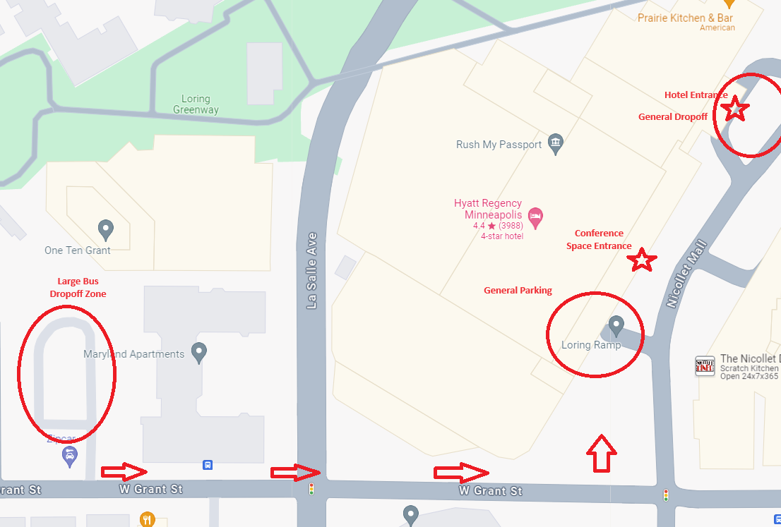

Standard sized vehicles, 6”6 and under (standard vans and pickup fit – check if you’re unsure)

- You can self-park in the Loring Ramp, 1330 Nicollet Ave, Minneapolis, MN 55403. This ramp is right next to the hotel although it’s officially a part of it. Parking is $25 a day if you elect to leave your car there (an extra $5 to come and go). The Loring Ramp does have a 6’6” clearance which could be too low for some vans.

Oversized parking options, over the 6”6” –but not suitable for buses due to length

- There is limited availability at hotel for valet parking for 6 oversized vehicles at $60 a night, first come first serve at the hotel.
- Use the 228 S 12 St Parking Garage
  - Recommend that you drop off your students and then go park (5-6 block walk)
  - Guarantee your spot using an app like, Parkopedia, ParkMobile, SpotHero or ParkWhiz
  - Or Buy a ticket from a pay station
- Benson Big Lot (Interstate Parking Lot #2113)- 200 South 10th St - the entrance is marked by a blue pay here booth with white lettering). This lot is a bit further away, a 5 block walk.
  - Recommend that you drop off your students and then go park (5-6 block walk)
  - Can book ahead with an ap here as well, Parkopedia, ParkMobile, SpotHero or ParkWhiz
  - Or Buy a ticket from a pay station

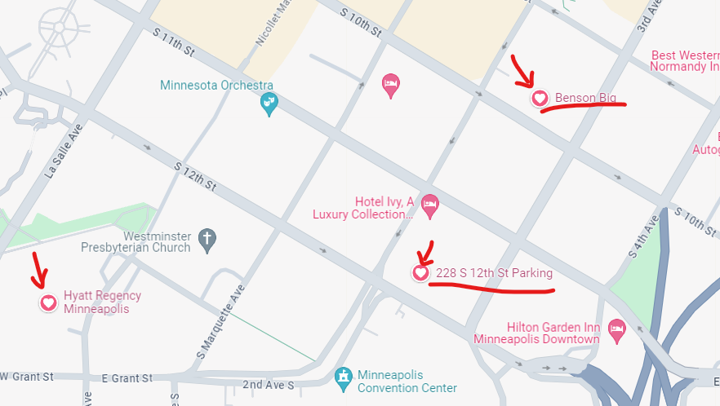

Overnight Bus Parking Options
- If your bus driver is staying overnight and not participating in conference activities, consider booking their room at another hotel with a parking lot they can keep the bus in.
- If you driver is a conference participant or a chaperone that needs to stay at the Hyatt, the only overnight parking option for a bus downtown is to get an overnight charter bus permit. Create an account and purchase that permit here. Park where old grey hound bus terminal is, 950 Hawthorn Ave, Minneapolis, MN 55403 (In between 9th and 10th off of Hawthorne ave). If you have problems you can contact John @ 763-639-0607.
- Let me know if you go this route and I’ll look to setup a volunteer to pick you up.

