Service Project Posters

You will need to work with your group to create a poster for the Service Parade. Make arrangements to work with your group and complete your poster ahead of SLC.

Make the poster one sided only. You should make it attractive with colored letters, photos, etc. Make the chapter name and project name at least 2.5 to 3 inch letters. Do not write on the poster in handwriting. Everything should be printed or cut out…..

The poster and your representatives will be in the parade.
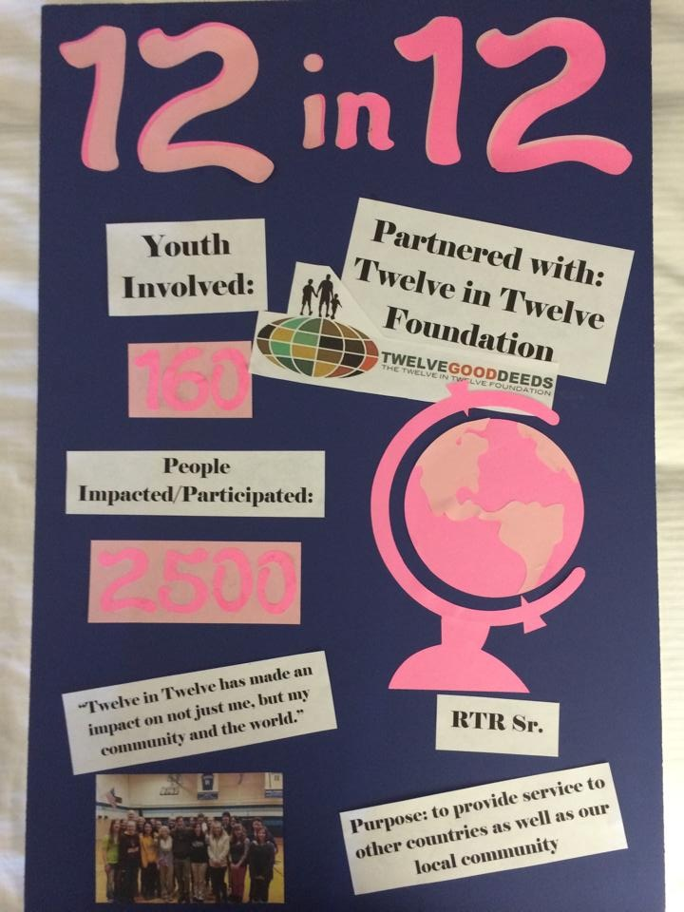
Things to Include on your poster (it should be a
lot like this one)

- Regular sized foam board or poster board
- Chapter name
- Service Project Titles
- Participant names
- # of persons impacted (involved in making
- the project happen and helped by the project)
- Photo of the project if possible
- Print outs of applicable icons/images
- Partners for your project ( for a example a business
that supported you, took your donations….)

Kindly write the follow on the back of you poster board:

Chapter name:____ _____________________________________________________
Name of Project: _______________________________
Chapter member(s) who will represent this project in the Service Fair and Parade:
1._______________________________________
2.__ _____________________________________
3.________________________________________

