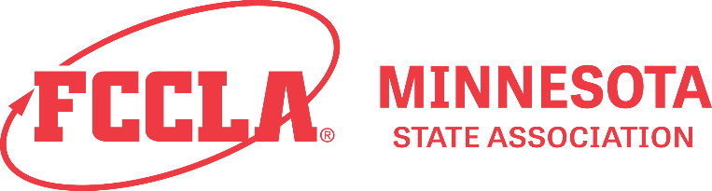
2024 State Leadership Conference Partnerships & Sponsor Opportunities

Promote your brand and support our next generation of leaders by partnering with MN FCCLA at our State Leadership Conference from April 7-9! Partners gain direct access to our 1500+ members, 75 Family and Consumer Science educators, and 500+ highly motivated conference attendees.
Please indicate your partnership type and complete the information below, thank you for your kind support!
☐ Ultimate Leadership Sponsor ($5000)
- Opportunity to address attendees at either the opening, closing, or awards ceremonies
- Your brand associated with the FCCLA Award of your choosing and the opportunity to present it to winners at the awards ceremony
- Your brand associated with a competitive event or feature conference event of your choosing and the opportunity to present awards for that competitive event, or address attendees at the feature event
- Recognized in remarks at the opening and closing ceremonies and on social media leading up to the conference
- Your logo displayed on it's own banner behind the registration desk, on the conference webpage, pre-conference attendee packet, on signage throughout the conference, and in follow up conference correspondences
- Complimentary exhibit space throughout the conference and a feature in program book.
YES: we would like an exhibit space for: ☐Sunday / ☐Monday/ ☐Both Days
☐ STAR Sponsor ($1000)
- Your brand associated with a competitive event or feature conference event of your choosing and the opportunity to present awards for that competitive event, or address attendees at the feature event
- Recognized in remarks at the opening and closing ceremonies and on social media leading up to the conference
- Your logo displayed on it's own 11x17 sign behind the registration desk, on the conference webpage, pre-conference attendee packet, on signage throughout the conference, and in follow up conference correspondences
- Complimentary exhibit space throughout the conference and a feature in program book
YES: we would like an exhibit space for: ☐Sunday / ☐Monday/ ☐Both Days

☐ Rose Sponsor ($500)
- Recognized in remarks at the opening and closing ceremonies and on social media leading up to the conference
- Your logo on the conference webpage, pre-conference attendee packet, on signage throughout the conference, and in follow up conference correspondences
- Complimentary exhibit space throughout the conference and a feature in program book
YES: we would like an exhibit space for: ☐Sunday / ☐Monday/ ☐Both Days

☐ Red Sponsor ($250)
- Your logo and a brief description in the conference program brook
- Your logo on the conference webpage, pre-conference attendee packet, on signage throughout the conference, and in follow up conference correspondences
☐ Contributing Sponsor ($100)
- Your logo on the conference webpage, pre-conference attendee packet, on signage throughout the conference, and in follow up conference correspondences

☐ Exhibitor Both days ($300) Exhibitor one day ($200) ☐Sunday, April 7
- listed in all print materials and on the website. ☐Monday, April 8

You can email this form to patrick.mitchell@mnfccla, call (651) 330-2950, or visit mnfccla.org/slc-partner.
If paying by check, please make checks payable to “Minnesota FCCLA” and mail with form to:

Minnesota FCCLA
PO Box 131386
Roseville, MN 55113

Amount Enclosed:

☐ Check (payable to MN FCCLA) ☐ Credit Card (MasterCard, Visa, Discover or American Express)

Credit Card Number: Credit Card Zip Code_____________

Expiration Date: __ CVV (Code on Back):

Institution/Organization/Individual (as you would like it to appear in conference materials):

Contact Person:

Phone: Email:

Please provide a brief description of your organization, group, or institution and the products, programs and offerings you would like highlighted in the program.

