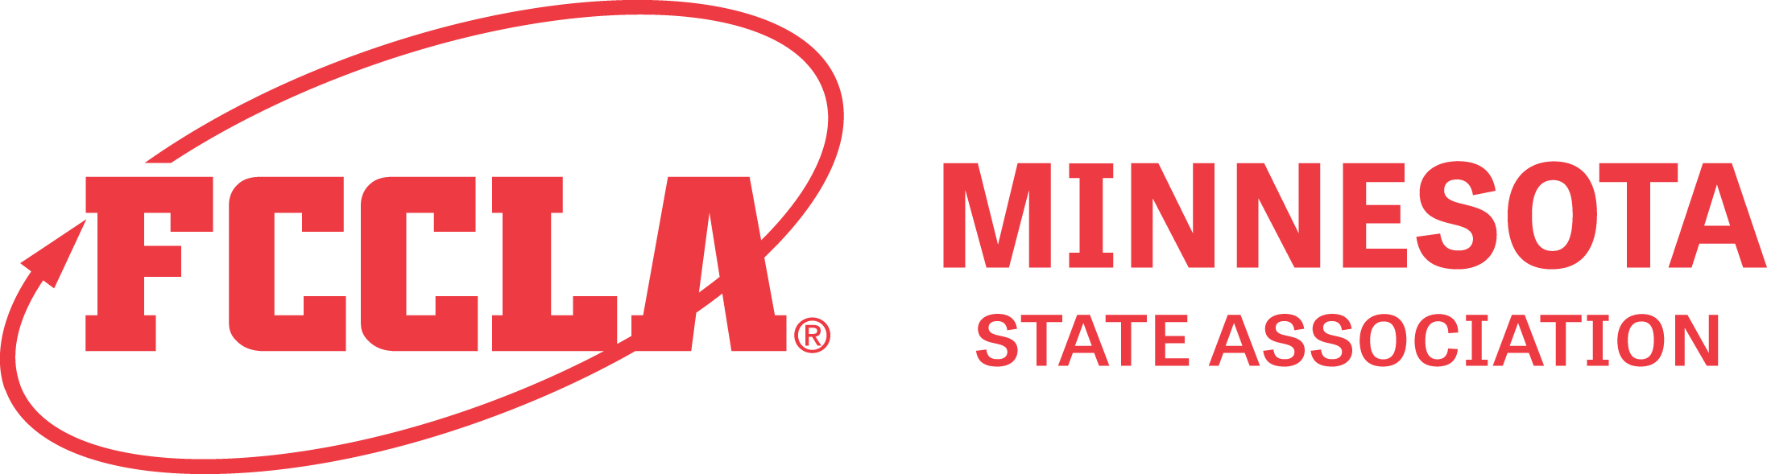

USE OF PHOTOGRAPHIC LIKENESS RELEASE- submit as application attachment

Name:____________________________________________________________

For good and valuable consideration, I authorize MN FCCLA and its agents to record photographs or other portraits or likenesses of me on videotape, audiotape, film, photograph or any other medium and use, reproduce, modify, distribute, and publicly exhibit such recordings, in whole or in part, without restrictions or limitation for any purpose that MN FCCLA deems appropriate. I further consent to the use of my name, voice and biographical material in connection with such recordings. I release MN FCCLA, its successors and assigns, agents, and all persons for whom it is acting from any liability by virtue of any blurring, distortion, alteration, optical illusion, or use in composite form, whether intentional or otherwise, that may occur or be produced in the recording process, or any unintentional misspellings or inaccuracies and waive any right that I may have to inspect or approve the finished recordings. I hereby release MN FCCLA, its staff, officers, members, partners, sponsors/funders, successors and assigns from and against any and all claims and causes of action whatsoever that I may hereafter have against MN FCCLA in connection with the above mentioned interview, written word, and/or photograph(s)/video.

Name: _____________________________________________________________________
FCCLA Chapter:____________________________________________________________________
Date signed:_________________________________________________________________________
Date of Birth:_______________________________________________________________________

Member Signature (if over 18 years)_____________________________________________________
or
PARENT RELEASE (Member is under 18 years of age)
Parent/ Guardian Signature:

____________________________________________________________________________________

