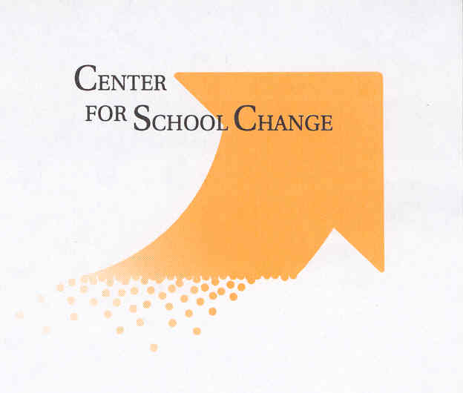

Service- learning resources:

- HSRA – CSC You-tube videos
https://centerforschoolchange.org/dual-credit/#foobox-6/0/FINAL-JumpStart-Update-3mbps-2014.mp4

https://centerforschoolchange.org/dual-credit/#foobox-6/1/FINAL-Success-Update-3mbps-2014.mp4

- CSC Service-learning resources (includes teacher prep standards, Furco 1 page research summary, students learning construction skills as they build homes for low income families, unemployment funds campaign, service-learning statement re teacher prep, etc. https://centerforschoolchange.org/projects/promoting-encouraging-greater-use-of-service-learning/ and https://centerforschoolchange.org/projects/

- Great website with dozens of sample service-learning projects:
www.whatkidscando.org -

- Humphrey School Capstone Project Info:
https://www.hhh.umn.edu/degree-planning/capstone-workshop-pa-8081

www.nylc – Vast array of information including https://nylc.org/k-12-standards/

State Policy Info

- New Minnesota Teacher Preparation standards (includes requirements for all prospective teachers to learn rationale and implementation of service-learning and project based learning)
https://mn.gov/pelsb/assets/Standards%20of%20Effective%20Practice%20-%2006.2023%20-%20Accessible_tcm1113-579957.pdf
Standard 5.2 “The teacher understands the value of and knows how to implement instructional approaches that integrate real-world learning opportunities, including service learning, community-based learning, and project-based learning, into instruction.”

ECS – State Service learning Policies https://www.ecs.org/?s=Service-Learning

Resources Middle School & Up Kids Can Read:

Lewis, Barbara, Kids Guide to Social Change (available on Amazon)

Sundem, Garth, Real Kids, Real Stories, Real Change (Free Spirit Press)

- -- - -

Center for School Change contact info: joe@centerforschoolchange.org,
khalique@khaliquerogers.com,
https://centerforschoolchange.org/

