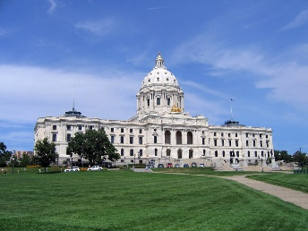
Save the Date
MN FCCLA Capitol Day
- An event for Advocacy about FCCLA and FCS Education
- An opportunity for MN FCCLA Officers and members to make an impact with public officials.
- Kick Off to Martin Luther King Day of Service in January
Please send your application by December 15, 2023.
Send to Wendy.ambrose@mnfccla.org
Or to: MN FCCLA PO Box 131386, Roseville, MN 55113
January 9, Monday at the State Capitol
Address: Minnesota State Capitol, St Paul, MN
Tentative agenda:
Morning: Make arrangements to visit with your own legislators- Capitol Area. Make appointments for a short visit and photo opportunities with your State House of Representatives and State Senators.
National Candidate Interviews- MN candidate’s first step in the process, Candidate test
Lunch: On your own at the Capitol cafeterias
1:00-3:00 pm MN FCCLA State Officers, alumni who have public service careers, Special guests L’Etoile Du Nord Room B 15- State Capitol
3:00 pm Group photo and depart

Sunday Evening Hotel arrangements. If you choose to come on Sunday evening for this Monday event, we will be able to stay at the Hyatt hotel. You will be able to experience the 2023 MN FCCLA State Conference Location hotel- Hyatt hotel.
HYATT REGENCY MINNEAPOLIS
1300 NICOLLET MALL
MINNEAPOLIS, MN, 55403
T: (612) 370-1234

We will be sending detail on how to reserve a sleeping room after Dec 14. We are making those arrangements for a reduced rate. Rooms will be available in a MN Block of rooms. Payment by your school or chapter.

Application to be involved in the 2023
January 9 Capitol Day for MN FCCLA
Please send your application by December 14, 2023.
Send to Wendy.ambrose@mnfccla.org
Or to: MN FCCLA PO Box 131386, Roseville, MN 55113

____Yes I will be attending the January 9 MN FCCLA Capitol Day.
Name:
Chapter:
___Chapter member
___Area Officer
___State Officer
___Adviser
___Guest/ chaperone
___Youth Council member

Email Address:
Phone number:
Registration cost: $ 20.00 Make check payable to MN FCCLA. Registration costs will help to cover some meeting room expenses.
My State legislators are:
House:
Senate:
___Yes, I will be contacting these persons for appointments to meet with them prior to or after the FCCLA Program.

Student Applicants: My goal or reason for attending the MN FCCLA Capitol Day is:

Please send you application by December 14, 2023.
Send to
Wendy.ambrose@mnfccla.org
Or to: MN FCCLA PO Box 131386, Roseville, MN 55113

