SILENT IMPACT CHALLENGE FOR MN FCCLA MEMBERS AND CHAPTERS

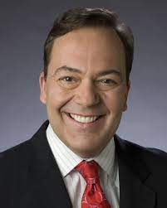At the 2021-2022 Minnesota FCCLA State Leadership Conference, members listened to Joe Schmit of KSTP in the Rotunda of the Mall of America. He gave a message of kindness and compassion that impacted two students in their senior year of high school.

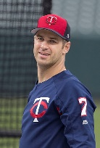 Joe Mauer graduated from Cretin-Derham Hall High School in 2001; coincidently, Joe Schmit had been covering Mauer’s high school athletics career. Twenty years later, Joe Schmit interviewed Mauer and another former student, Mike Hally. Hally is legally blind and did not have any particular similarities with Mauer. Hally was not athletically involved or among his class’s popular and cool kids. Having known Hally as a peer, Mauer invited him to sit at his table, the “cool kids” table of the cafeteria.

See You Tube video: No One Sits Solo - The Story of Joe Mauer & Mike Hally
https://www.youtube.com/watch?v=g6tLNupgJBs&ab_channel=ThumbsUpHigh5K

Because of this, Hally became one of the “cool kids” and a friend of Mauer’s. When the bell rang, Mauer helped Hally to his next class. In “Silent Impact: Stories of Influence through Purpose, Persistence, & Passion,” Joe Schmit writes, “Mike was a kid who could have been ignored or shunned because of his disability, but Joe made him one of the cool kids. Imagine the impact it had on Joe’s friends and other students at the high school. The ripple effect of Joe’s actions in high school is even more impactful now, given his rise to athletic fame. We make our biggest impressions when we are not trying to be impressive.”

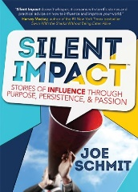As members of FCCLA, we can learn quite a bit from Silent Impact. Joe Mauer did not have to invite Mike Hally to eat with him and his friends, yet, he did it. Because of this, he made a “silent impact” on his friends and Mike. His friends started helping Mike to class, which broke barriers for Mike. He didn’t have to be alone. He gained the courage to meet new people while also giving others the ability not to be afraid of him or his condition.

Minnesota FCCLA wants you to make a Silent Impact in your school, community, and family this year. Maybe your chapter can turn a Silent Impact campaign into any individual, group, or chapter project.
A great example of this is a non-profit organization called Thumbs Up. Its mission is to understand the value of life and help others talk about mental help. Your Silent Impact project does not need to be an elaborate and extensive campaign. Simply doing small acts of kindness in your community can make for significant change. A silent impact project would also fit under several National Programs, including Student Body, Families First, Power of One, or Stand UP.

Complete a Silent Impact project as a Service project for Martin Luther King Jr day or as a Leadership project, a STAR Event.
To learn more, view this You Tube story done by Joe Schmit.
https://www.youtube.com/watch?v=g6tLNupgJBs&ab_channel=ThumbsUpHigh5K

Report on your project to enable MN FCCLA to collect data on the service projects.

Report due by January 9, 2023 to:
Joe Dagel, State President Elect

10 IDEAS FOR A SILENT IMPACT PROJECT

____Identify a new student who needs a friend and befriend them at lunch time.

____Seek out an elementary school student who could use a new friend and become a new friend to them.

____Find an elderly person in your community who would be cheered with spending time with you, getting a gift or a greeting card occasionally.

___Say thank you to someone in your community who does not get enough recognition and make them feel special for their work.

___Do a Thank You card campaign for janitors, cooks and other service personal in your school.

___Do a special project to thank the school bus drivers who work with students everyday.

___Make a silent impact at a sports event with a show of sportsmanlike behavior to the opposite team and their fans.

___Make a special effort to do a special day for special needs people, DAC or other agencies who work with special people.

___Offer to do babysitting, child care or other helping chores for a single parent in your community.

___Volunteer with your special needs teachers to identify someone who could use your friendship.

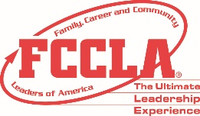
MN FCCLA SILENT IMPACT PROJECT REPORT- Due January 9, 2023 or before

State FCCLA President Elect Joe Dagel
Or Send report to adviser Tammy Borman by email: tammy.borman@rtrschools.org

Address: Russell Tyler Ruthton High School, 111 Co Rd 8, Tyler, MN 56178

******************************************************************************

1. Name:
2. Chapter:
3. Email:
4. Phone

5. Describe what your Silent Impact project was about:

6. Who benefitted from your Silent Impact project?

7. How many other people or partners were involved in your Silent Impact project?

8. What was the result of your Silent Impact project?
What happened because of this project?

9. How many people were served?

10. How many hours did your Silent Impact project involve?

11. Check the type of service this Silent Impact represented:

___Social/ emotional health
___Homework help
___Understanding others
___Positive peer pressure
___Positive mental health
___Teen resiliency
___Finding common ground and talking with someone who is different than you
___Developing leadership skills for a younger person at school.
___Developing academic skills with a student who needs a tutor.
___Creating social acceptance for/ with others
___Helping under resourced students
___A collaborative project with your Silent Impact partner on environmental issues, a leadership project or a shared talent or skill
___Other:

12. What did you learn about yourself because of this project?

13. Send a photo of your Silent Impact project in action.

