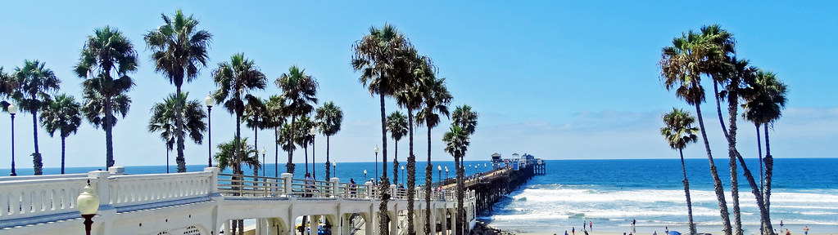Minnesota Delegation to National FCCLA Conference 2022
State Meetings and Events
We are excited to have a large delegation planning to be at the National FCCLA Conference in San Diego. As part of the state plans, we are expecting to have these State FCCLA meetings and events.
- June 29, 2022 4:00 pm State Meeting- Convention Center
- July 1, 2022 6:30 pm departure- Minnesota delegates Charter Bus Trip- Sunset at the Ocean.
- July 2, 2022 2:00 pm State Awards-STAR Event medals to MN delegates- Convention Center
July 1 Minnesota group event. July 1 is a night for states to plan something. The conference does not have NLC events scheduled.
MN group registration: We would ask advisers or chaperones for each school group to claim your seats using the survey monkey link. https://www.surveymonkey.com/r/5L68228 Respond before June 1
Cost: $0 (MN FCCLA is securing the charter buses.) 2 Buses ( tentatively) have been reserved with a specific number of seats available. Please respond before June 1. Supper or snacks are at your own expense. The beach is a public beach area. Your expenses: Supper or snacks
CALIFORNIA OCEANSIDE NIGHT
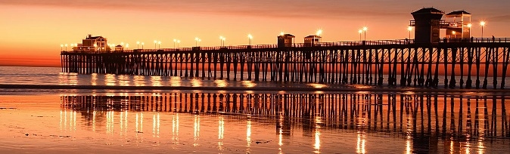 As part of the Minnesota package, we are planning a charter bus trip to Oceanside (38 miles) to the Oceanside Pier. En-route, we will stop for supper (dutch treat- your own expense) at a location where you can grab some supper. We will be at the Oceanside Beach for sunset and to watch the surfers. A few food venues are also at the beach. Grab you camera, your casual wear or swim wear, and sit to watch the sunset or wade into the ocean. This pier is one of the largest wood piers in the USA and usually a good spot to watch the surfers, and sea life.

We will wait for the Election Voting Delegate to cast their ballot and then be leaving from the Hilton San Diego Bayfront: Gull Street (Lower Level Entrance).

- Can you decide later? No, we need a confirmed number for the bus reservation.
- Can extra people come along? No- It is for the MN Package registered persons.
- Where will we eat? Once the survey link responses come, we will see if we need special meals, and this may influence where we go to get supper.
- What can we wear? Casual clothes, take or have beach wear, be ready for some casual Oceanside time.
- Can delegates go without their adviser or chaperones? No.
Draft Itinerary:

San Diego Convention Center-near Hilton San Diego Bayfront: Gull Street (Lower Level Entrance).
111 W Harbor Dr San Diego, CA 92101
Departure time: 07/01/22 - 06:30 PM

Oceanside Pier
Oceanside Pier CA. Estimated arrival: 07/01/22 - 07:15 PM
Departure time: 07/01/22 - 08:30 PM

Oceanside
Oceanside, CA. Estimated arrival: 07/01/22 - 08:45 PM
Departure time: 07/01/22 - 09:15 PM

San Diego Convention Center
111 W Harbor Dr San Diego, CA 92101 Estimated arrival: 07/01/22 - 10:00 PM

