NOTE: These are tentative times & locations – check the conference app daily to confirm.
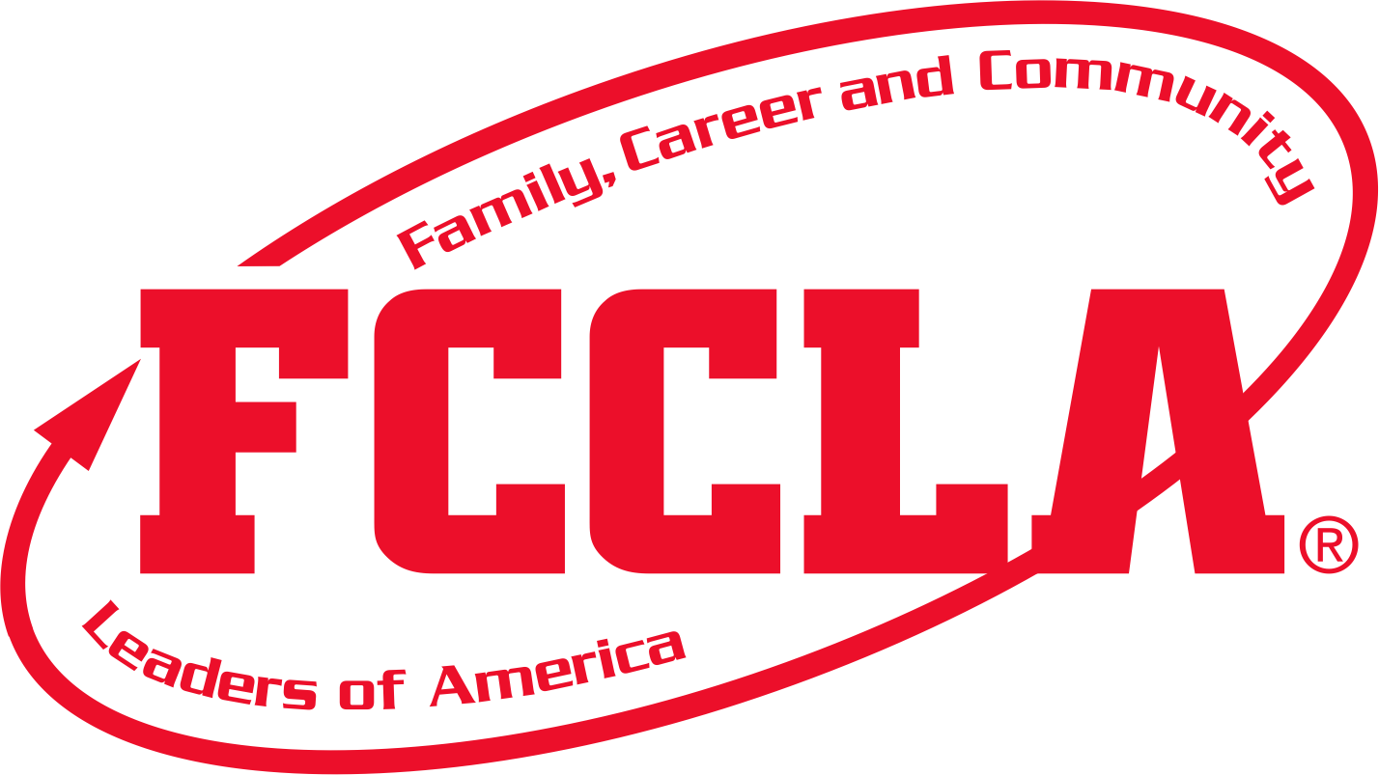
DRAFT: As of 5/16/22 FAMILY, CAREER AND COMMUNITY LEADERS OF AMERICA
2022 National Leadership Conference – San Diego

MINNESOTA Delegation Schedule = EntireMINNESOTA Delegation; = State Officers Voting Delegates STAR Events Advisers State Staff

Monday, June 27 | Wednesday, June 29 | Thursday, June 30 | Friday, July 1 | Saturday, July 2 | Sunday, July 3
Tuesday, June 28  Day 1  Travel Day for some chapters.  2:00-8:00 p.m.: State Staff will be in various State Advisers’ Meetings & Reception – Location: Location: SDCC Room 33C  IMPORTANT NOTE:  This daily schedule does not provide a complete listing of each day’s activities. Check the NLC app for more details, such as activity descriptions, special appointments, and details on activities you have pre-registered to attend. | Day 2  8:00 a.m.–6:00 p.m.:  Conference & STAR Events Packet Pick-up (Advisers only) Exhibit Hall H  7:00-8:45 a.m. Location TBA – Breakfast & rehearsals for MN state officers  11:30 a.m. –1:30 p.m.: Hall of Fame Awards Luncheon –Lori Henry, Wendy Ambrose  1:00–2:00 p.m.: Youth Networking – Mission Mayhem  2:00-3:00 p.m. or 3:15-4:15 p.m.: First Time Attendees Orientations for Advisers or for Students-Locations:  2:30–4:00 p.m.:  Lead / Assistant Lead Consultants Meeting –Wendy is LC for NPA  Location: SDCC Room 31ABC  3:00–4:00 p.m.: State Officer Training (pre-register) Location:  3:00-4:00 p.m.: FCCLA CSI Problem Solver Session by Gayla & Teresa – SDCC Room 21 (state staff)  4:00 – 5:00 p.m.: Minn State Meeting:  Location: Room 31 ABC  6:00 – 8:00 p.m.  Opening General Session  San Diego Convention Center  Exhibit Hall F&G  Doors open at 5:00 | Day 3  7:30 a.m.–4:00 p.m.: EXPO & FCCLA Store-Exhibit Hall H  7:30 -8:30 a.m.: STAR Events Room Consultants, Volunteers & Evaluators meeting – see app for your event location.  8:00–9:15 a.m.: NOC & Voting Delegates Orientation-Exhibit Hall F&G  8:30–9:15 a.m.: Knowledge Bowl Volunteer Orientation -SDCC Room 10  9:00 a.m.-4:00 p.m.:  STAR Event Competitions See app for specific events & locations.  9:00–11:45 a.m.  Exhibit Hall H:  Red Talks in 15-minute intervals and/ or Youth Workshops-See topics in NLC app.  9:30–10:00 a.m.: Knowledge Bowl Team Orientation-SDCC Rm 10  10:00 a.m. –12:30 p.m.: Knowledge Bowl Pool Play  1:30-3:15 p.m.: Knowledge Bowl Quarter/Semi-Finals  2:00–3:30 p.m.:  Exhibit Hall H  Youth Workshops and/or Red Talks in 15-minute intervals until 3:45  2:00–3:30 p.m.: Advisers’  Best Practice Exchange – Exhibit Hall H-Round table discussions on various topics  4:00-4:30 p.m.: Voting Delegate Sign-In – Ex. Hall F&G  4:30–5:30 p.m.  Business Session  Exhibit Hall F&G  7:30–10:00 p.m. Run4Red 5K Run/Walk – Hilton Bayfront Park preregistration required | Day 4  7:30 a.m.–4:00 p.m.: EXPO & FCCLA Store-Exhibit Hall H  7:30 -8:30 a.m.: STAR Events Room Consultants, Volunteers & Evaluators meeting – see app for your event location.  8:00-8:45 a.m.: Nat’l Off. Candidates Meet/Greet Location: TBD  9:00 a.m.-4:00 p.m.: STAR Events See app for events and locations.  9:00–10:45 a.m.-Exhibit Hall H Red Talks n 15-minute intervals  9:00–11:00 a.m.-Exhibit Hall H  Youth Workshops -See topics in NLC app.  9:00–11:00 a.m.: Advisers’  Best Practice Exchange – Round table discussions on various topics-Exhibit Hall H  9:00-11:00 a.m.: Location: ?  Voting Delegates Networking with NOC – State Officers’ Lunch  12–12:30 p.m. Exhibit Hall F&G  Voting Delegate Check-In for  Officer Candidate Speeches –  12:30–1:45 p.m. Group A (NEC, Voting Delegates & Spectators)  2:00–3:15 p.m.: Group B (NEC, Voting Delegates & Spectators)  3:15 p.m. State Officers Caucus with Wendy  2:00–3:15 p.m. Exhibit Hall H Red Talks in 15-minute intervals and/or  Youth Workshops -See topics and locations in NLC app.  5:00-6:30 p.m. NEC Elections  (Election V Del)  6:30 p.m. Boarding Bus for Surf’s Up in Oceanside Pier trip for MN delegates  Location: Bus loading at Hilton Bayside  Trip ends at 10:00 p.m. | Day 5  8:00–11:00 a.m.:  FCCLA Store  8:30–10:30 a.m.  Exhibit Hall H:  Spotlight on Projects and STAR Events and/or  Youth Workshops-See topics in NLC app.  8:30-10:30 a.m.: State Officer Networking – SDCC Room 20A preregistration required  8:30–10:30 a.m. Chapter & State Adviser Roundtables – SDCC Room 28 A-E  9:30–10:30 a.m.:  State Adviser Professional Development  SDCC Room 26AB  11:00 a.m.–1:00 p.m.  Recognition Session  3:00–9:00 p.m.:  Special Event: San Diego Zoo (pre-purchased event ticket required)  Election Voting Delegate:  5:00 pm on Friday -  Cast election ballot. | Day 6  7:15-7:30 a.m.:  Competitive Events Awards Ceremony Volunteers report to Holding Room-Exhibit Hall H  7:45–8:30 a.m.: Competitive Events Awards Ceremony Finalists report to Holding Room-Exhibit Hall H  8:30–9:30 a.m.:  State Advisers Only –  STAR Events Results Pick-Up SDCC Room 22  10:00 a.m. –12:00 p.m. Exhibit Hall H Competitive Events Awards Ceremony – All Regions  2:00–3:00 p.m.:  MINNESOTA STAR Events  Recognition Session-Location: SDCC 25ABC  5:00–6:30 p.m.  Closing General Session  Exhibit Hall H  7:30–10:30 p.m.  Marriott Marquis Grand & Pacific Ballroom  FCCLA NLC After Party (pre-purchased event ticket required)  Monday, July 4  Day 7  Travel home for most chapters. Have a safe trip!  For example: letter pick up times, Nominating Committee interview time, Fishbowl, etc.  Skyler:  5:00 pm on Friday:  Cast VA election ballot.

