MINNESOTA FCCLA 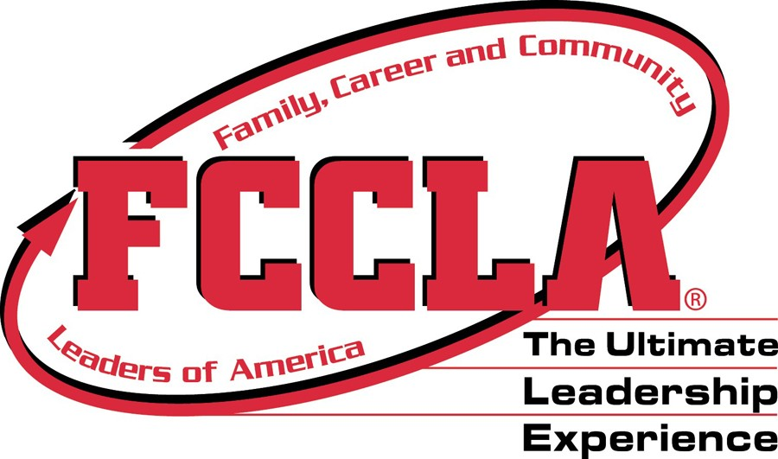
Leadership Conference 2022 San Diego, California

Important policies:
- The Board of Directors has endorsed the plans for National Conference.
- Delegates from MN FCCLA will represent the state association. The delegates represent the state, not just the local chapters.
- Delegates and chaperones are expected to attend all General Sessions. (and stay until the session is completed even if delayed or running long.)
- The delegates are expected to attend and participate in state meetings.

Steps:
- Send to Minnesota FCCLA, PO 131386, Roseville, MN 55113

FORM A
Minnesota FCCLA Package:
Register with MN FCCLA for MN package by April 28
. All delegates, chaperones, STAR Event participants and Advisors will pay a nonrefundable payment by Early May if you are attending. Late fee after the deadline will add $25.00.

FORM B
Memorandum of Understanding agreement between schools and advisors must be signed and sent to the State FCCLA office for delegates to attend without their own advisor. (FORM B).

IMPORTANT! A Memorandum of Understanding agreement between schools and advisors must be signed and sent to the State FCCLA office for delegates to attend without their own advisor.
(FORM B)If a youth delegate is chaperoned by someone other than their advisor- the Memorandum of Understanding Form is needed.

FORM C
Health Form- Code of Conduct, Health Forms and mail to MN FCCLA by April 28.

FORM D
Code of Conduct- mail to MN FCCLA by April 28.

FORM E
Notification of Chapter Plans to MN FCCLA

May 4
Registration with National FCCLA May 4 for STAR Event delegates, Later in May for others.

National Conference Registration- On-line with National FCCLA. Delegates will register with National FCCLA for Conference registrations and the various options for the conference.
(ON-LINE with www.fcclainc.org)
Deadline for STAR Event participants is May 4.
STAR Event participants must be entered as a conference participants before entering STAR Events. Late fees are the responsibility of the chapter.

May 4
STAR Event National Entry – May 4-On Line with National FCCLA by May 4.

After you register with national FCCLA, the information about hotels will be shared with you. Hotel rooms are available in a number of hotels secured by National FCCLA. Chapters will choose their own hotel location. There is not a state delegation hotel. Hotels are available on a first come, first secured basis.

A state meetings will be held at a couple of dates and locations. To be determined.
(State Photo date and time is TBD)
State Meetings of the Minnesota delegation are for information, for state delegation duties and for learning about and representing your state association. These are mandatory.
MN delegation will sign in and out of the meetings. Chapters who have STAR Event, region, JHC, Peer Ed, STAR Event or candidates who are not in attendance will NOT receive their STAR Event results directly. They will be sent to the school with a letter explaining your non-participation in state required meetings.

We have requested these dates and meeting locations for MN FCCLA state meetings.

For your use: A sample letter for parents from chapter advisors was included in the State Conference information.- Use this PRIOR to the State Conference.

DUE April 28 ALL FORMS and MN Package Must be in our hands by April 28
MINNESOTA PACKAGE FORM A
National FCCLA Conference
Check payments included:
Amount due April 28 -Non refundable

I. PARTICIPANT INFORMATION
Name:_____________________________________School:___________________________
Home Address:__________________________________________________________________
(Town), MN_____________________________ (Zipcode) ___________________
Home phone:(____)____________________ Cell phone:(____) __________________

Check one: ____ Advisor ___ Other Adult ___Member ___Other youth

Grade of member or youth participant:___________

T shirt size: ____S; ____M; _____L;____XL;_____XXL;_____XXXL;____
(Students only) RED JACKET SIZE:_____________________________________________
Backpacks are not a part of this 2022 State package. You can order them form National FCCLA Store if desired.

II. If Student: Please fill in this information
Parent:______________________________________________________________
Work phone:(___)________________________ Cell phone:(____) __________________
Parent 2:______________________________________________________________
Work phone:(___)________________________ Cell phone:(____) __________________
State FCCLA will not locate roommates for you.
DEADLINE: _______________________
MN FCCLA Package: pins, a conference logo t shirt, insurance, MN per person fee, Management fee.
As determined by the Board of Directors policies for National FCCLA Conference.
Check one:
___$130.00 | Persons in an individual STAR Entry-INDIVIDUAL IN STAR EVENT | $130.00 _____
___$110.00 | Persons in a two person team event-STAR Events-TWO PEOPLE IN STAR EVENT | $110.00 _____
___$100.00 | Persons in a three person STAR Event-THREE PEOPLE IN STAR EVENT | $100.00 _______
___$ 90.00 | Persons in a team event TEAM EVENT OF MORE THAN 3 | $90.00________
___$85.00 | Persons with no STAR Entry (Adults, Advisers and non STAR Event persons) NOT IN STAR EVENT | $85.00________
Sent to: MN FCCLA PO 131386, Roseville MN 55113
After April 28- Add $25.00 late fee
Mail to MN FCCLA, PO 131386, Roseville, MN 55113
Make checks payable to MN FCCLA.

Delegate Memorandum of Understanding
PERFORMANCE CODE FOR FCCLA NATIONAL CONFERENCE
DUE: __________________ FORM B
Mail to MN FCCLA, PO 131386, Roseville, MN 55113
Name of person attending. School:_______________________________
- I realize that I represent MN FCCLA and what I do and say should leave a favorable impression. I will refrain from using alcohol, drugs or tobacco products.
- I will wear the dress code for the conference. I will be neat in dress and personal appearance and wear official officer dress code or organizational clothing when representing FCCLA.
- I realize that cell phone use, text messaging and communicating to friends and family not at the conference will be limited to non-conference times. (Early morning or late night) I will inform friends and family that I will have limited times to communicate unless it is an emergency. The focus of my time will be to network, to represent FCCLA and to be focusing on the conference that I am attending.
- I will keep all appointments, network with persons at the conference, be prompt and prepared.
- I will be knowledgeable about the organization and its programs and the events of MN FCCLA.
- I will maintain a positive attitude about the other FCCLA representatives and MN FCCLA. I will not speak negatively of another officer, member or advisor.
- I will abide by the NLM Conference rules, MN delegation rules and hotel rules while attending the conference.
I agree to the above policies:
Member signature_____________________________ Date:______________
Chaperone Signature:__________________________________________________
Advisor Signature:_____________________________________________________
************************************************************************
Authorization Form
Please return with NLM registration to
Wendy Ambrose, MN FCCLA, PO 131386, Roseville MN 55113 Phone: 651-330-2950
Name: ________________________________________________________________
Date of meeting: _______________ Location: __________________________________
Mode of transportation to/ from home: _____________________________
Person accompanying officer: _________________________________________
We, the undersigned, understand that the above named individual will be in attendance at this meeting. We give our approval for this individual’s participation. We agree not to hold Minnesota FCCLA or any of its agents liable for any accident, or injury to this individual during participation in state authorized FCCLA activities and necessary travel to and from sites. Please submit this form to the state FCCLA office prior to the event. We do verify that we (officer, parent/guardian has read and understand the policies.
Signatures:
FCCLA member : ___________________________ Date: ___________________________
Parent/Guardian: _____________________________Date: __________________________
Health Form NAT’L CONFERENCE FORM C
Directions: DUE ___________ Please complete and sign this form and return a copy to your advisor and a copy to the State FCCLA Office with registration. Send to MN FCCLA, PO 131386, Roseville, MN 55113
Name:_____________________________________
Date of Birth:________________________________
Home Address:______________________________
City, State , Zip:______________________________
E mail address:______________________________
Phone:(Home)______________________________
Phone Work________________________________
Phone Cell:_________________________________
School name:_______________________________
Physician:_______________________________
Physician phone number:____________________
Is student presently under medical care or taking a prescribed medication? ____Yes ____No
If yes, describe the medication/s:

Is person allergic to any medication?
____Yes ____No If yes -list medication/s.

Does participant have any health problems?
e. g. Diabetes, pregnancy, seizures, allergies
____Yes ____No

If yes- please describe any special care that is needed.

*******************************************************
Family Contact: __________________________________
Family member address:___________________________
______________________________________
City/ State/ Zip:______________________
Phone: Home_________________________
Work:_______________________________
*******************************************************
Medical Insurance:
Name of company:______________________
Name of insured:_______________________
Policy number:_________________________
Insured ID Number:_____________________

I, _____________________________________, ___________________ hereby
(name of parent /guardian) ( relationship to student)
authorize in advance any necessary medical treatment as required in the judgment of the attending physician while the student is absent from home and attending an FCCLA event.
Even though your son/ daughter may be 18 years of age, he/she will be subject to the rules of the conference (according to the age of majority, distributed by the Minnesota Dept of Education and the Attorney Generals’ office) he/ she will not be allowed to possess or drink alcoholic beverages, possess or use non prescription drugs or smoke/chew tobacco.
1. Will you support your son/ daughter/s advisor and the FCCLA Executive Director in enforcing these rules?
___Yes ___No
2. Infringement upon these regulations requires that the student will be sent home from the conference at your expenses. Will you see to it that your son/ daughter is picked up at the conference if such a procedure becomes necessary? ___Yes ___No

3. I give my son/ daughter permission to swim in the hotel swimming pool and I will not hold Minnesota FCCLA responsible. ____Yes _____No

IN CASE OF EMERGENCY PLEASE CALL
Name of first choice______________________________________________________________________________________
Work phone(____)___________________________________ Home Phone(____)_________________________
Cell phone(____)___________________________________
Name of second choice__________________________
Work phone_(____)___________________________________Home Phone(____)_______________________
Cell phone(____)___________________________________
Parent Signature:_____________________________________________________________________
Date: ________________________________________
Mail to MN FCCLA, PO 131386, Roseville, MN 55113

FORM D
Chapter Plans –Notification to the State FCCLA Office

Please send notification of your chapter plans to the State FCCLA Office.

Deadline: April 28
Mail to MN FCCLA, PO 131386, Roseville, MN 55113

Please make a copy prior to submitting on line and attach a copy of your housing rooms and conference registration to the MN Package forms.
Please return this information to the MN FCCLA State office

MN FCCLA, PO 131386
Roseville, MN 55113
mnfcclashelly@mnfccla.org

Information about the Chapter Delegation to the National FCCLA Conference

Chapter:_______________________________________________________

Number in your delegation:_______________________________________

Attach information about

- Delegates and rooming list

- Delegates conference registrations (Conference options selected) Tours and gala tickets that you have submitted for.

- Travel Plans.

__________________________________________________________

4. Send the Chaperone Memorandum of Understanding if delegates are travelling without their Advisor and coming with another group.
Memorandum of Understanding FORM E
Substitute Advisor Chaperoning of FCCLA delegates not from their own chapter.
This Memorandum of Understanding is for use in the event that National FCCLA Conference delegates who may be attending the National FCCLA conference without their chapter advisor accompanying them.
The National FCCLA policy for chaperones in 1 chaperone per 4 delegates.
This is an agreement between the school of the delegate attending and the school of the substitute Advisor who will be chaperoning the student delegate
This agreement is between ____________________________________(school of the student delegate) and Chapter Advisor _____________________________________________who has agreed to be a substitute chaperone for the student delegate:________________________________
ATTENDING THE CONFERENCE
Delegate name to be chaperoned:_________________________ Age ________Gender____
School of the delegate attending____________________________________________
Substitute Chaperone: _________________________________________ Gender_______
Chapter advisor who will be chaperoning this delegate
Phone number of the advisor attending_________________________________
E mail of the advisor attending_______________________________________
Cell phone of the advisor attending___________________________________
Cooperating School of the substitute advisor attending____________________________
This advisor will have a total of ____ students to chaperone.
NOT ATTENDING THE CONFERENCE
Advisor to the delegate who will not be attending:____________________ Phone of the advisor not attending__________________Email of the Advisor not attending___________________________
Cell phone of the advisor not attending___________________________
____Yes, we hereby agree to cooperate to chaperone and guide this student to the National FCCLA Conference and will be responsible for their attendance, travel and participation from home to the conference and return.
___Yes, I have read, reviewed the policies with the student and will enforce the National Conference and state delegation policies for this delegate.
Any financial agreements between the two schools are subject to your own negotiations.
Signed:_________________________________________________Date_________________
School of delegate
Signed:_________________________________________________Date_________________
FCCLA Advisor of delegate
Signed:_________________________________________________Date_________________
School of substitute advisor
Signed:_________________________________________________Date_________________
Substitute Advisor
Adviser/Chaperone Responsibilities
Advisers are responsible for the behavior and discipline of their students throughout the conference. Students causing a disturbance or displaying inappropriate behavior will be asked to leave the conference and the hotel. An adult must accompany and supervise all students at a ratio of one adult for every four students. Male chaperones
should supervise male students. National headquarters will not provide supervision for students traveling alone. There is a 12:00 midnight in-room curfew each night. This curfew should be enforced by the advisers and will be strictly enforced by the hotel security. This curfew is for the safety of the students and in respect for the other guests staying at the hotel(s).
Mail to MN FCCLA, PO 131386, Roseville, MN 55113

