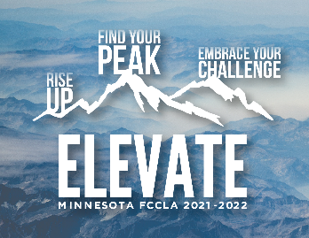
2021-22 State Theme: ELEVATE!
MN FCCLA State Goals
- Membership- reinstate chapters who dropped during covid, increase state membership, increase efforts for inclusion, attract lump sum chapters.
- MN FCCLA will increase membership to over 4500 members in 2021-22.
- Membership campaigns will include national membership packages, invite diverse membership, and seek to include co curricular chapters.
- Service Efforts for 911, MLK day, GYSDAY
- MN FCCLA will conduct 3 service campaigns to involve 500 students or more at each. Chapters will report their projects and results by deadlines.
- 911 Day of Service- 500+ students involved
- MLK Day of Service -500+ students involved
- Global Youth Service Day of Service-500+ students involved.
- Program Accomplishments.-National Programs, STAR Events.
- The 7 National Programs will have award applications from 35 chapters.
- STAR Events participation will increase to over 1000 involved in midwinter level and 900 in state level.
- Increase sponsorships for individual and corporate support for MN FCCLA programs and state conference.
- Power of One participants in 5 units
- 75 or more members will do the 5 units of Power of One and apply for national recognition to receive state recognition.
- 50% of chapters have members who do at least 1 Power of One module.
- Fall Webinars- Chapter engagement.
- FCCLA series of webinars done by Area and State Officer teams will be viewed by chapters.
- Area and state officers will conduct 5 webinars which will be viewed by 80% of the chapters.
- Public Relations
- 70% of the chapters will do FCCLA Week activities.
- 50% of chapters will submit articles to Horizon and 25% to Teen Times.
- 50 examples (Articles, photos, project reports) of public relations efforts will be done and reported on the website.
- Chapter Operations
- 85% of chapters hold regular chapter meetings and use FCCLA ceremonies, train officer teams.
- Chapters will use the State Theme for promotion of FCCLA.
- State and National Involvement
- Area Officer candidate applications will increase 100%. 20+ candidates in 2022
- State Officer candidate applications will increase 20%. 25 candidates in 2022.
- 40 chapters or more attend the Fall Conference.
- 900 or more members attend State Conference 2022.

