FCCLA LEADERSHIP
CAMP 2021
With Leadership Training by Patrick Grady (invited)

EARLY NOTIFICATION: PLEASE USE THE SURVEY MONKEY LINK TO SPECIFY YOUR EXPECTED ATTENDANCE BY JUNE 8 to begin working with the hotel room assignments.
https://www.surveymonkey.com/r/RPR96MX

FCCLA LEADERSHIP CAMP
August 1-3, 2021
“Center Stage-“Find your place on it!”
Doubletree Bloomington Hotel
7800 Normandale Boulevard, Bloomington, MN 55439
FCCLA CENTER STAGE
“FIND YOUR PLACE ON IT!”

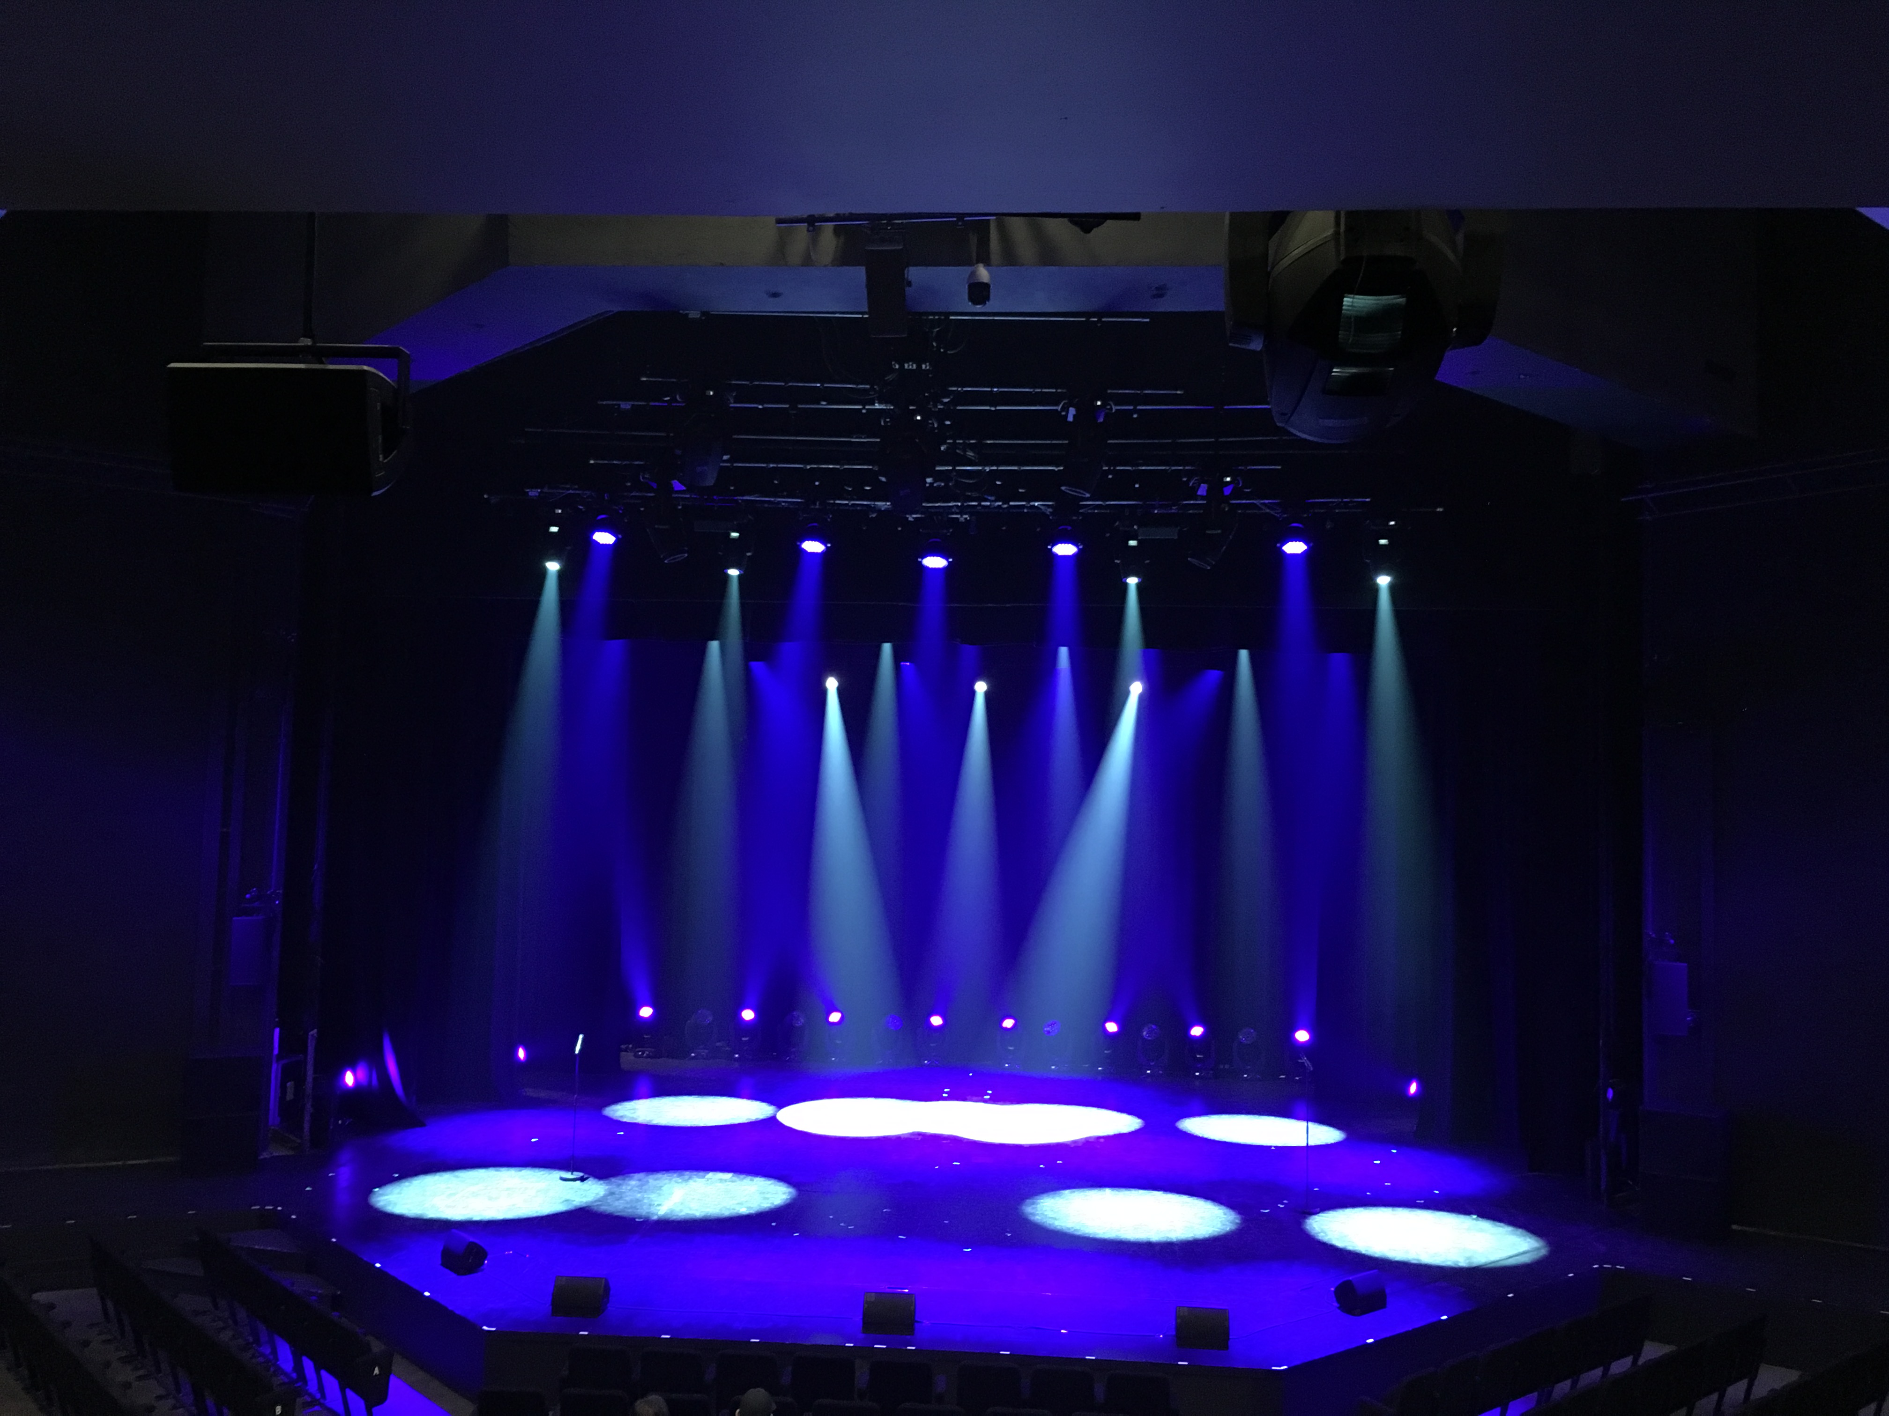
2021 FCCLA Leadership Training Camp
Individual Registration-Due June 21
PLEASE USE FORM PER EACH PERSON REGISTERING
Name:_______________________________________________Chapter:________________________

Check one: ____Chapter Leader ____State Officer
____Area Leadership Team Officer____ JHC ____National Officer/ candidate ____Guest _____Potential Adviser ____Adviser ____Chaperone
Home Address: __________________________________________________________________ ___Male ___Female
Town____________________Zipcode_________________ Phone (______)-____________________Grade:_______
Cell phone (______)-_________________E mail (summer)____________________________________

Do you need special meal considerations?: ___________Yes.. Describe the need:__________________________
___Vegan meal ____Vegetarian meal ___Allergy to food:___________________________

Camp attire: Khaki or black slacks or Capri length. FCCLA polo shirt, white, red or black shirt or FCCLA t shirts
Double rooms will be assigned by MN FCCLA unless specified.
STUDENT OFFICERS
State  Officer  (double room) | Double room option  State Officers-Registration fee and lodging/ meals  Double room option  Roommate preference:__________ | August 1 Sunday evening through August 3 morning | $0.00
State  Officer  (single room) | Single room option  State Officers-Registration fee and lodging/ meals  Single room option | August 1 Sunday evening through August 3 morning | $140.00
Area Officer  (double room) | Double Room Option  Area officers  Registration fee and lodging/ meals  Double room option  Roommate preference:__________ | August 1 Sunday evening through August 3 morning | $85.00
Area Officer  (single Room) | Single Room Option  Area officers  Registration fee and lodging/ meals  Single room option | August 1 Sunday evening through August 3 morning | $140.00
ADVISERS/ CHAPERONES
Adviser  (double room) | Double room option Area and Advisors/ Adult Chaperone-Registration fee and lodging/ meals  Double room option  Roommate preference:__________ | August 1 Sunday evening through August 3 morning. | $285.00
Adviser  (single room) | Single room option  Advisors/Adult Chaperone-Registration fee and lodging/ meals  Single room option | August 1 Sunday evening through August 3 morning. | $425.00
Officer or adviser | Virtual Attendance or make up fee for non attendance | TBD
 | Late fee After July 1 Add $15.00 | Received after July 1
 |  | TOTAL | TOTAL $
RED JACKET RENTAL for 2021-2022 |  | Add $25.00

, code of conduct and check
Health Form MN FCCLA FCCLA Camp Training
Directions: Please complete and sign this form and return a copy to your advisor and a copy to the state FCCLA office by June 21
Student name: ______________________________________________________
Date of Birth: ____________________
Home Address: _____________________________________________________
City, State, Zip:______________________________________________________
Student email: _______________________________________________________
Phone: (Home)________________________________
Cell: ________________________________
School name________________________________Family Physician:__________________
Physician phone number:_____________________________________

Is student presently under medical care or taking a prescribed medication? ____Yes ____No
If yes, describe the medication/s:

Is student allergic to any medication? ____Yes ____No If yes -list medication/s.

Does your son/ daughter have any health problems? e. g. Diabetes, pregnancy, seizures, allergies?
____Yes ____No
If yes- please describe any special care that is needed.

Parent/ Guardian Name: ________________ Parent Address:_______________________
City/ State/ Zip: ________________________________
Phone: Home or cell _________________________
Work:_______________________________
Medical Insurance:
Name of company:______________________ Name of insured:_______________________
Policy number:_________________________
Insured ID Number:____________________
I, _____________________________________, (name of parent /guardian)( relationship to student)
authorize in advance any necessary medical treatment as required in the judgment of the attending physician while the student is absent from home and attending an FCCLA event.

Even though your son/ daughter may be 18 years of age, he/she will be subject to the rules of the conference (according to the age of majority, distributed by the Minnesota Dept of Education and the Attorney Generals’ office) he/ she will not be allowed to possess or drink alcoholic beverages, possess or use non prescription drugs or smoke/chew tobacco.
Will you support your son/ daughter/s advisor and the FCCLA Executive Director in enforcing these rules?
___Yes ___No
Infringement upon these regulations requires that the student will be sent home from the conference at your expenses. Will you see to it that your son/ daughter is picked up at the conference if such a procedure becomes necessary? ___Yes ___No
Signature:___________________________________
Date:_________________________

In Case of Emergency Call:
Name of first choice______________________
Work phone (______)________________________Home Phone (______)________________________
Cell phone (______)_________________________
Mail Registration, health form, and check to: MN FCCLA PO 131386, Roseville, MN 55113
Parent/Guardian Permission Form
Student name
First name Last name

Directions: This form is to be returned to the LOCAL ADVISOR and used by the local advisor.
ADVISORS: Keep a copy and bring a copy of these forms for the state conference registration files.
The Minnesota Association of the Family, Career, Community Leaders of America will hold Leadership Training August 1-3, 2021 at Doubletree Bloomington Hotel, Bloomington, MN. . Please fill out the questions below if your daughter or son is to be one of the representatives to this training. Forms must be returned before your delegate may attend.
**Transportation for camper will be provided by:________________________________________ (to arrive)
***Transportation home will be provided by:___________________________________________ ( to leave)
- Do you approve of your son or daughter attending the State FCCLA Training to be held at the Doubletree Bloomington Hotel?. | YES | NO
- Do you approve of your son or daughter participating in leadership activities? | YES | NO
- Do you know the plans for the trip, including who will chaperone the group, the mode of travel? Do you approve of these plans? | YES | NO
- Do you expect your son or daughter to see or call relatives or friends while en route to or in Bloomington? If yes, please write the name and address of relative and/or friend: _____________________________________________ | YES | NO
- Do you plan for your son or daughter to leave the group at any time while traveling to or in Bloomington? If yes, please explain: ___________________________________________________________ | YES | NO
- Does your son or daughter agree to abide by the rules of no use or possession of alcohol, drugs or cigarettes as well as the camp curfew? | YES | NO
- Does your son or daughter give permission to use likeness in a photograph or other digital reproduction in any and all of its publications, including website entries, without payment or any other consideration. I further give permission to MN FCCLA to share this image with its partners for use in any and all of its publications, including website entries, without payment or other consideration. I understand and agree that these materials will become the property of Minnesota FCCLA and will not be returned. | YES | NO
VIOLATION OF THESE RULES WILL RESULT IN THE PARENT COMING TO LEADERSHIP CAMP TO GET THE STUDENT OR FINANCING TRANSPORTATION HOME IMMEDIATELY.
Name two persons who may be contacted in case of an emergency
- Name Phone
- Name Phone
Explain any special care needed:
_____________________________________________________________________________
By signing this, I agree to the terms stated above.
- Signature of Parent: ____________________________________Date:________________
- Signature of Delegate: _________________________________Date: ________________
- ADVISORS: Keep a copy and send a copy of these forms.

2021 FCCLA Leadership Training -Delegate Code of Conduct--Make 2 copies
Please return a copy of this signed code of conduct to your chapter advisor.
The advisor should bring the copies of the code of conduct to hand in at registration or send it with the registration and also keep one copy for your own use.
Due June 21

Name:_____________________________________ Chapter:____________________________

I realize that attending MN FCCLA Leadership Training is a responsibility and an opportunity to attend one of the finest youth events in the state. As a delegate from my chapter, a representative of my school and community,

I agree to act in a professional manner.
____ Yes, I agree to attend all sessions for delegates and take full advantage of the training.
____ Yes, I agree to attend all sessions and be respectful of the speaker, presenters and fellow delegates
____ Yes, I will promote and demonstrate the positive image of a positive youth leader.
____ Yes, I will refrain from the use or possession of alcohol, drugs or tobacco during the training.

____ Yes, I agree to abide by all rules of conduct set by the State Association and the rules set by my FCCLA chapter advisor and chaperones.

____ Yes, I will be respectful of campus property and the property of other delegates and roommates.

____ Yes, I hereby grant Minnesota Association of Family, Career and Community Leaders of America permission to use my likeness in a photograph or other digital reproduction in any and all of its publications, including website entries, without payment or any other consideration. I further give permission to MN FCCLA to share this image with its partners for use in any and all of its publications, including website entries, without payment or other consideration. I understand and agree that these materials will become the property of Minnesota FCCLA and will not be returned.

Signed: ______________________________________________________ Member

Signed: ______________________________________________________ Parent

Signed:_______________________________________________________Chapter advisor

2021 MN FCCLA Leadership Camp Draft Agenda

Camp attire: Khaki or black slacks or Capri length. FCCLA polo shirt, white, red or black shirt or FCCLA t shirts
Doubletree Bloomington Hotel, 7800 Normandale Boulevard, Bloomington, MN. 55439
Sunday, August 1, 2021
Leadership training- with Patrick Grady (invited)
STUDENTS/ADVISORS
Supper prior to arrival
Registration 6:00-6:30 pm
Leadership Training/Networking 6:30 pm- 8:30 pm
FCCLA Activities 8:30 pm-9:30 pm
Free time/getting acquainted 9:30 pm- 11:30 pm
Curfew 11:30 pm

Monday- August 2, 2021
Breakfast at hotel 7:00 am- 8:00 am
Morning Session 8:00 am- 11:00 am
Center Stage activity 11:00 am-12:00 pm
Lunch at hotel 12:00 pm- 1:00 pm
Camp Activity 1:00 pm- 3:00 pm
Officer Team Training 3:00 pm- 4:00 pm
Speaker 4:00 pm- 5:30 pm
Dinner at hotel 5:30 pm- 6:30 pm
State Officer Round Tables 6:30 pm- 8:30 pm
Advisor Resource Work 8:30 pm- 10:00 pm
Lip Sync Prep Time 8:30 pm- 10:00 pm
Lip Sync Presentations 10:00 pm- 11:30 pm
Curfew 11:30 pm

Tuesday- August 3
Check out of hotel rooms
Breakfast at hotel 7:00 am- 8:00 am
Morning Session 8:00 am- 11:00 am
Closing Session 11:30 am- 12:00 pm
Departure and eat lunch enroute home.

MN FCCLA ANNUAL RENTAL OR NEED FOR RED JACKETS
Due June 21

Each 2021-2022 State Officer and Area Officer should submit this form.

Name of Officer:______________________________________________________
Chapter:____________________________
NOT NEEDING A JACKET:

____I do not need an annual jacket rental as I have a personal jacket.

NEEDING A JACKET:
____I will return a jacket from a prior year and need a different size.

___I do need a jacket rental for April 2021-April 2022.
Size of jacket I need is:____________________

___I have a jacket from a prior year such as 2019-2020 or 2020-2021 and will keep that jacket. I will pay the new annual rental fee of $25.00 for 2021-2022 and will not return that jacket.
The number of that jacket is:_______________

RETURNING JACKETS:
All State and Area Officers who had a prior year’s jacket and not planning to use it as the 2021-2022 rental should return jackets to the state office by June 30.
Late fees will be assessed for non-returned jackets after June 30.
The cost of not returning a jacket is $65.00.

WHERE TO SEND:
Send jackets to be returned to: MN FCCLA, PO Box 131386, Roseville, MN 55113
Jackets need to be returned by June 21, 2021 for inventory and cleaning.

Make $25.00 rental checks payable to MN FCCLA.

Send to:
MN FCCLA
PO 131386, Roseville, MN 55113

