Regional Administrators: During and after STAR Events
See the DASHBOARD below for the ability to see what is being /has been done by the judges during the evaluation period
Judge Pro Dashboard
Dashboard
Click on the “Dashboard” button located in the Menu at the top of the screen
This dashboard is a real-time view of what evaluations have been scored by Judges and what evaluations are still outstanding
Total Entries – Students/Teams Registered in the Event
#Scored – Number of Evaluations Scored by Judges for the Event
%Scored – Overall Percentage of Evaluations Scored by Judges for the Event
#Submitted – Number of Evaluations Submitted by Judges for the Event
%Completed – Overall Percentage of Evaluations Completed by Judges for the Event
Submitted to CMS – Number of Scores that have been sent to the Conference Registration CMS

***Towards the close and after the Evaluation Period has ended
Event Evaluations
Judge Pro Event Evaluations
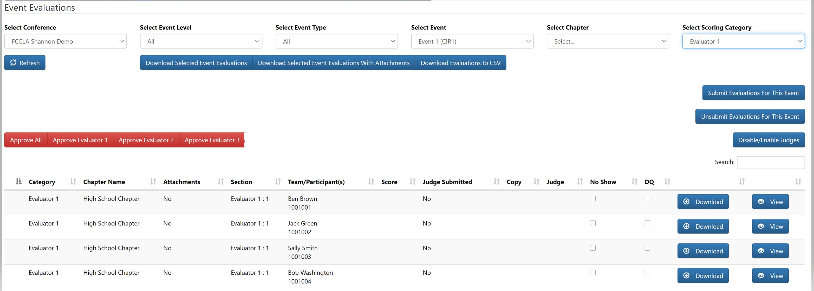
Select Conference – The current conference will be selected by default
Select Event Level – You can choose all events to display on the screen or you can filter by the Event Level (May not apply to all CTSO’s)
Select Event Type – You can choose all events to display on the screen or you can filter by the Event Type (May not apply to all CTSO’s)
Select Event – Filter by the Event
Select Chapter – Filter by the Chapter
Select Judge – Filter By Judge
Download Selected Event Evaluations button – This will download judge’s evaluations that are being displayed on the screen.
Download Selected Event Evaluations With Attachments button - This will download judge’s evaluations that are being displayed on the screen with student attachments. DO NOT RUN THIS UNTIL YOUR CONFERENCE IS OVER AS IT TAKES A LONG TIME TO COMPILE THE FILE.
Download Evaluations to CSV button -
Event Evaluations Continued
Judge Pro Event Evaluations
Submit Evaluations for This Event button – If all evaluations have been scored by judges in this event and they have not submitted their evaluations, click on this button to submit all evaluations for this event
Un-submit Evaluations for This Event button – If you need to release the rubrics back to the Judges, click on this button to un-submit all evaluations for this event
Disable/Enable Judges – This option allows you to Disable a Judge or Scoring Category
Search Bar – This option allows you to search on the Event Evaluation screen by Chapter Name, Students, Submitted Date and Judge Name
No Show – This option allows you to mark no shows. If you mark no shows prior to Judges scoring, the students will not show up on the Judges list of students to score
DQ – This option allows you to DQ students. If you mark DQ’s prior to Judges scoring, the students will not show up on the Judges list of students to score
Download – This option allows you to download the evaluation for the individual student
View – This option allows you to View the Student Evaluations, Reset Evaluations, Submit Evaluations, Un-sign/Un-submit back to Chapter Advisers, Release project back to Student, override scenario view time (if applicable), add or remove files for student, set penalty, un-submit single evaluation back to Judge
Approve All, Approve Judge 1 – The approve buttons are unique to each CTSO; however, they all do the same thing. They send scores to the CMS in your Conference Registration system. Based on your setup for scoring, this will determine what buttons will appear hear to send scores over. For example, if you have RP1 and RP2, this means you have scores for both point categories that need to be sent to the CMS for the event. If you have Judge 1, Judge 2, Judge 3, that means, you have scores from 3 Judges for this event.

Utilities | Prepare Chapter Downloads After your recognition session
Click on the “Utilities” button located in the Menu at the top of the screen
Click on “Prepare Chapter Downloads” from the drop-down menu
Note: A dialog box will appear: Do not run this if you are at Conference. This process will take a very long time. Please do not close your browser or navigate away until it is finished. Are you sure you want to run this process?
Click on the “Yes” or “No” button
IMPORTANT: This function is what you run once the conference is OVER. DO NOT run this function until everything has been completed for your Conference. This function prepares the Judge’s Rubrics and Comments for each Chapter. Once this is run, the Chapter Advisor can log into the Conference Registration system and download their students Rubrics/Comments to give to their students. The System Admin must turn on this option in Conference Registration for this feature to be offered to Chapter Advisors located in Setup/Preferences/Conference Management or CMS – the naming might be different between conference registration systems.

Reports Menu
Judge Pro Report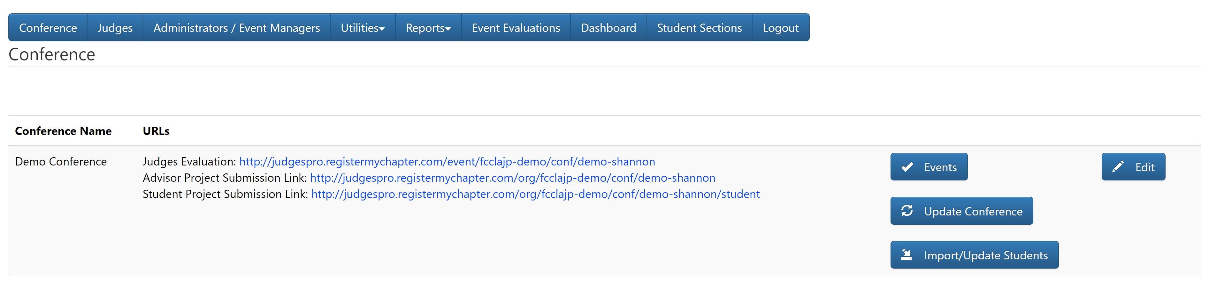
Click on the “Reports” button
IMPORTANT INFORMATION:
- Event Evaluations Report - This report will generate a .CSV file of the Event Evaluations
- Summary Report - This report will generate a .CSV or PDF file with the status events completed in the Judges system (similar to the dashboard)
- Download All Event Evaluations for Conference – This report should ONLY be run when everything has been completed in the Judges System and your Conference is over. When you run this report, all Judges Evaluations for all Events will be downloaded into a Zip File. This report takes a long time to compile all of the information and to download.

How to Log Out
- Click on the “Log Out” button

