Regional Adviser Instruction for setting up virtual STAR Event Judging Site

After Jan 7. In the Registration system
- REPORTS>Event Reports>Participants w/o Events-catches participant not assigned to an event
- REPORTS >Registration reports>Registration Problems- this shows issues causing chapter register completion problems
- REPORTS >Registration reports>unfinished Registrations -shows school that have NOT clicked “finish Registering”. You will have to do it if you can’t get ahold of them to.

- If you want to see the events you have, go to Reports>Event Reports> by event individual. THEN be sure to click on Participant, all the levels and team event. Produce report.
- You will want a list of all the volunteers with their information to use with the Judge Pro program. Do the following:
Utilities>export data> click on CSV. Then go down and choose Volunteer Job Selections. You will get a spread sheet that you can adapt to the one needed for Judge Pro.

Judge Pro – Regional Administrators substitute your region number
Add your own login
Your username = your email

Import/Update Students
When you click on the “Import/Update Students” button, the following is updated:
- Adds and/or Updates Conference Registration Students to Judge Pro
- Adds and/or Updates Conference Registration Student Sections to Judge Pro
- Updates existing Student Team Captain, Member ID, Grade and Regional ID
IMPORTANT: The above buttons would be used once you are ready to bring over students and/or schedule sections from the Conference Registration system. Also, if you have a rubric that is not showing up in the Event Setup area, once the issue is resolved, you would click on the Update Conference button
Step 7 – Judge Pro Event Setup and Settings
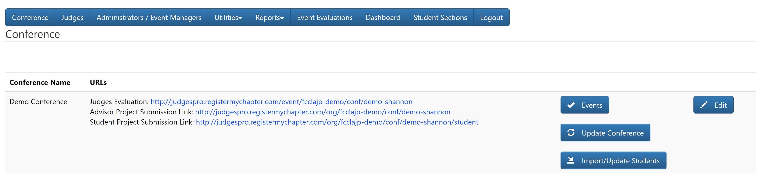
- Click on the “Events” button
Note: Each CTSO will have their own set of events and Event Settings; however, the core setup is the same for all CTSO’s
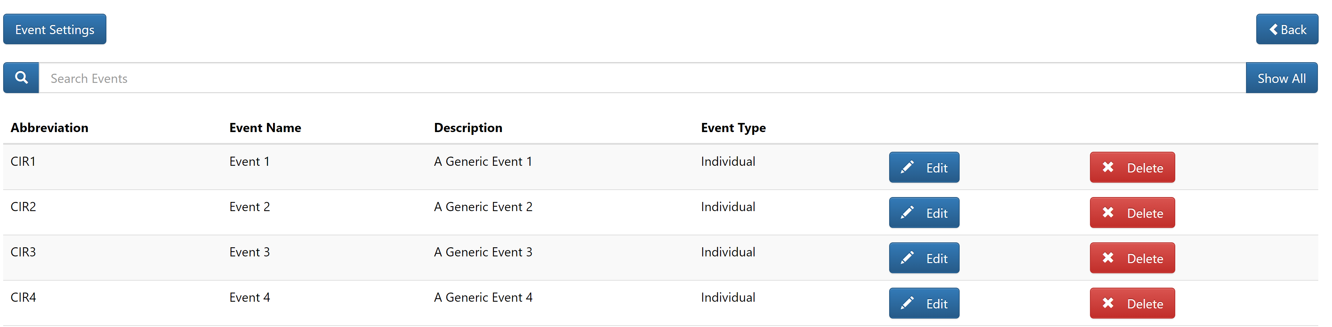
- Click on the “Event Settings” button
Step 7 – Judge Pro Event Setup and Settings Continued
Judge Pro Rubric Preview
Note: Each CTSO will have their own set of events and Event Settings; however, the core setup is the same for all CTSO’s. For example, in the image below, most CTSO’s will not have a room consultant; however, if you look at the next image, that would be more typical of what would be displayed – Each CTSO is unique.)WAFCCLA HAS A ROOM CONSULTANT.
Example 1
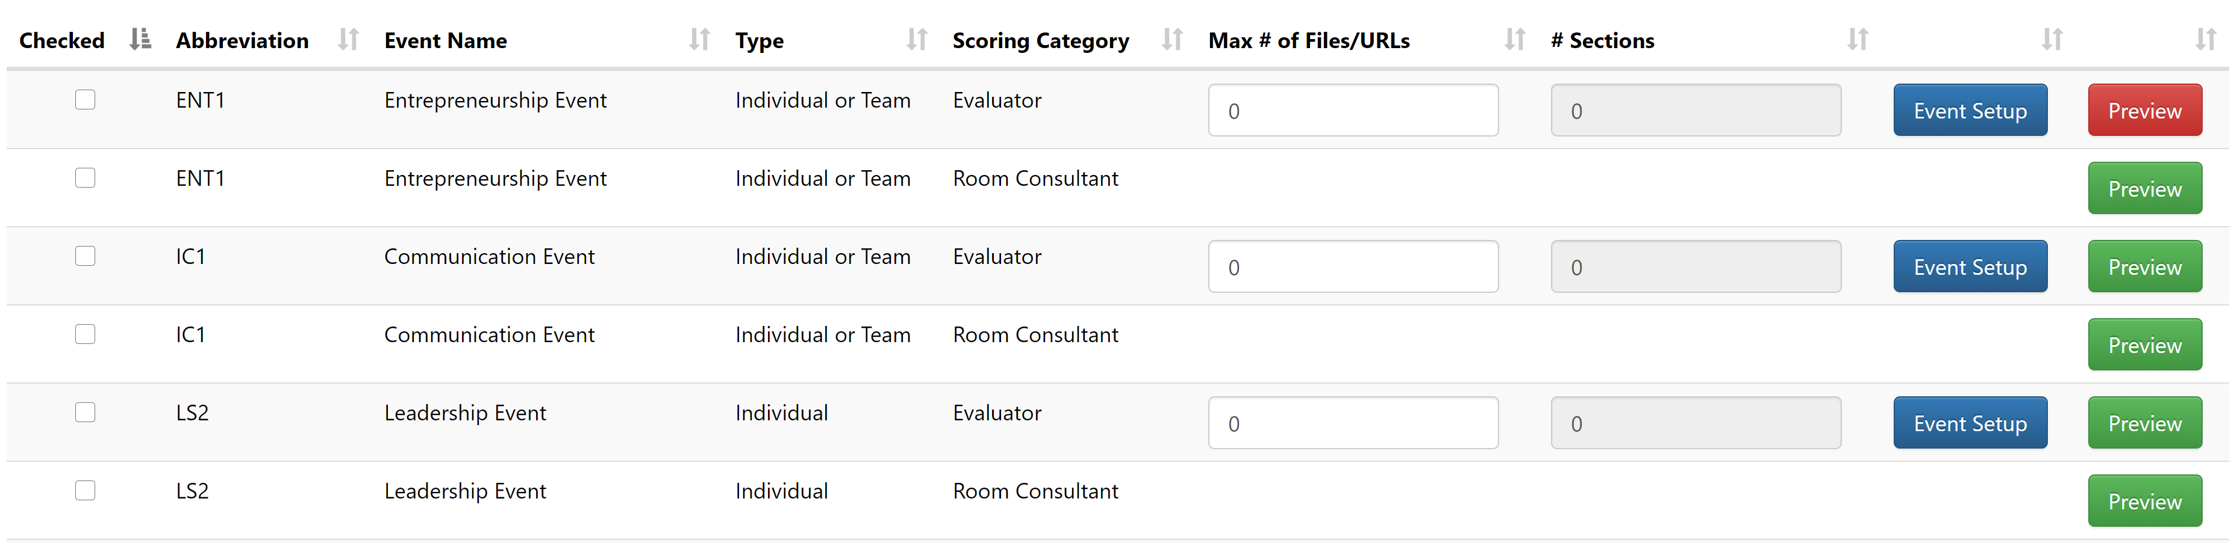
Example 2
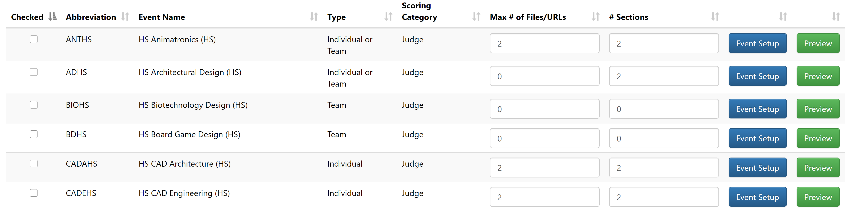
- Type in the appropriate “Max# of Files/URL’s” in the Max# of Files/URLs field for each Event THESE FILES HAVE BEEN SET.
Note: you can use Mass Update to update all of the events. Max files/urls allowed for student upload is three (3) -30 MG each

Step 7 – Judge Pro Event Setup and Settings Continued
Judge Pro Student Sections (Superficial Sections)
IMPORTANT – READ BEFORE PROCEEDING: If you imported sections from the Conference Registration system, then SKIP the Judge Pro Section instructions. Judge Pro Sections are “Superficial Sections” meaning, the sections created are purely used to divide students into sections and assign those sections to Judges. If you choose to use the “Superficial Sections” in the Judge Pro Site, then when the scores go back to the CMS, the students will not go back in sections that was created in Judge Pro. The students ONLY go back in sections if the students came over from the conference registration in sections. If you want to calculate places based on sections in the CMS, then you MUST create the schedule sections in the Conference Registration system.
- Type the appropriate “Sections” in the “#Sections” field located on the right-hand side of the Event
Note: Repeat one-by-one until you have all sections added or you can use the “Mass Update” button to update multiple events at one time
- Click on the “Student Sections” button located at top in the Main Menu

Step 7 – Judge Pro Event Setup and Settings Continued
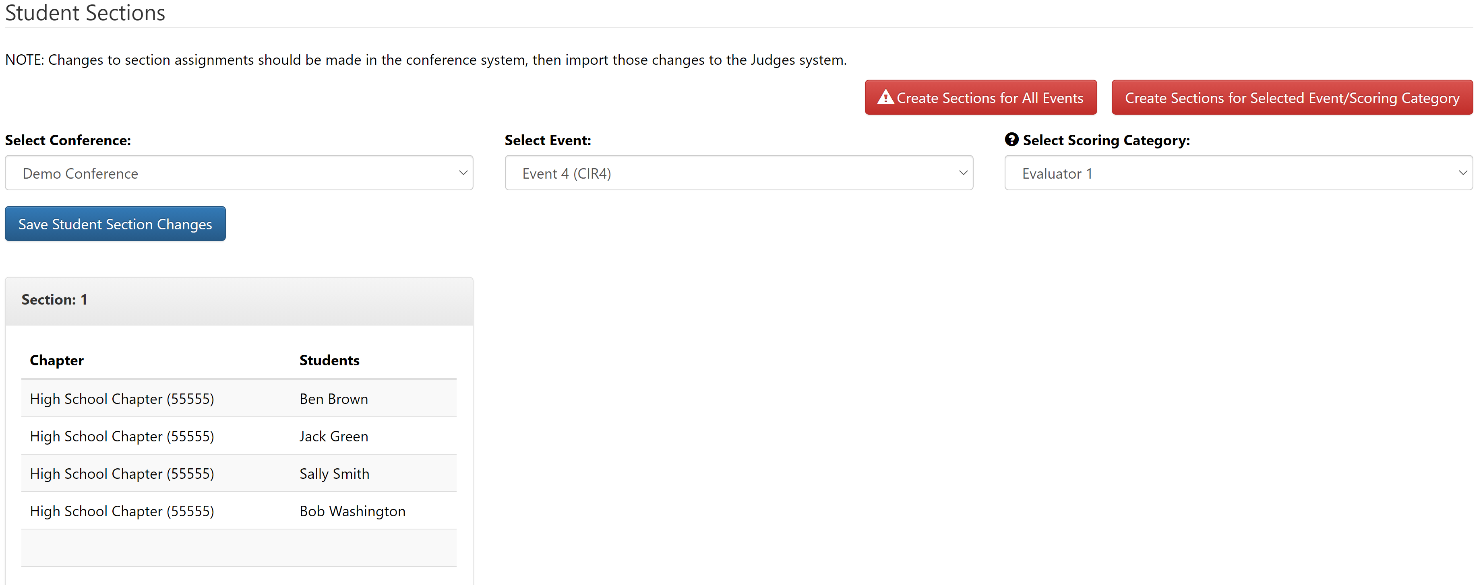
IMPORTANT: THIS FUNCTION SHOULD ONLY BE USED PRIOR TO JUDGES EVALUATING STUDENT PROJECTS
- Click on the Down-Arrow located on the right-hand side of the “Select Conference” field
- Select the appropriate “Conference” from the “Select Conference” drop-down list
- Click on the Down-Arrow located on the right-hand side of the “Select Event” field
- Select the appropriate “Event” from the “Select Event” drop-down list
- Click on the “Create Sections for Selected Event/Scoring Category” button
Note: This will allocate the students, as evenly as possible, between the number of sections you setup for the event

Step 7 – Judge Pro Event Setup and Settings Continued

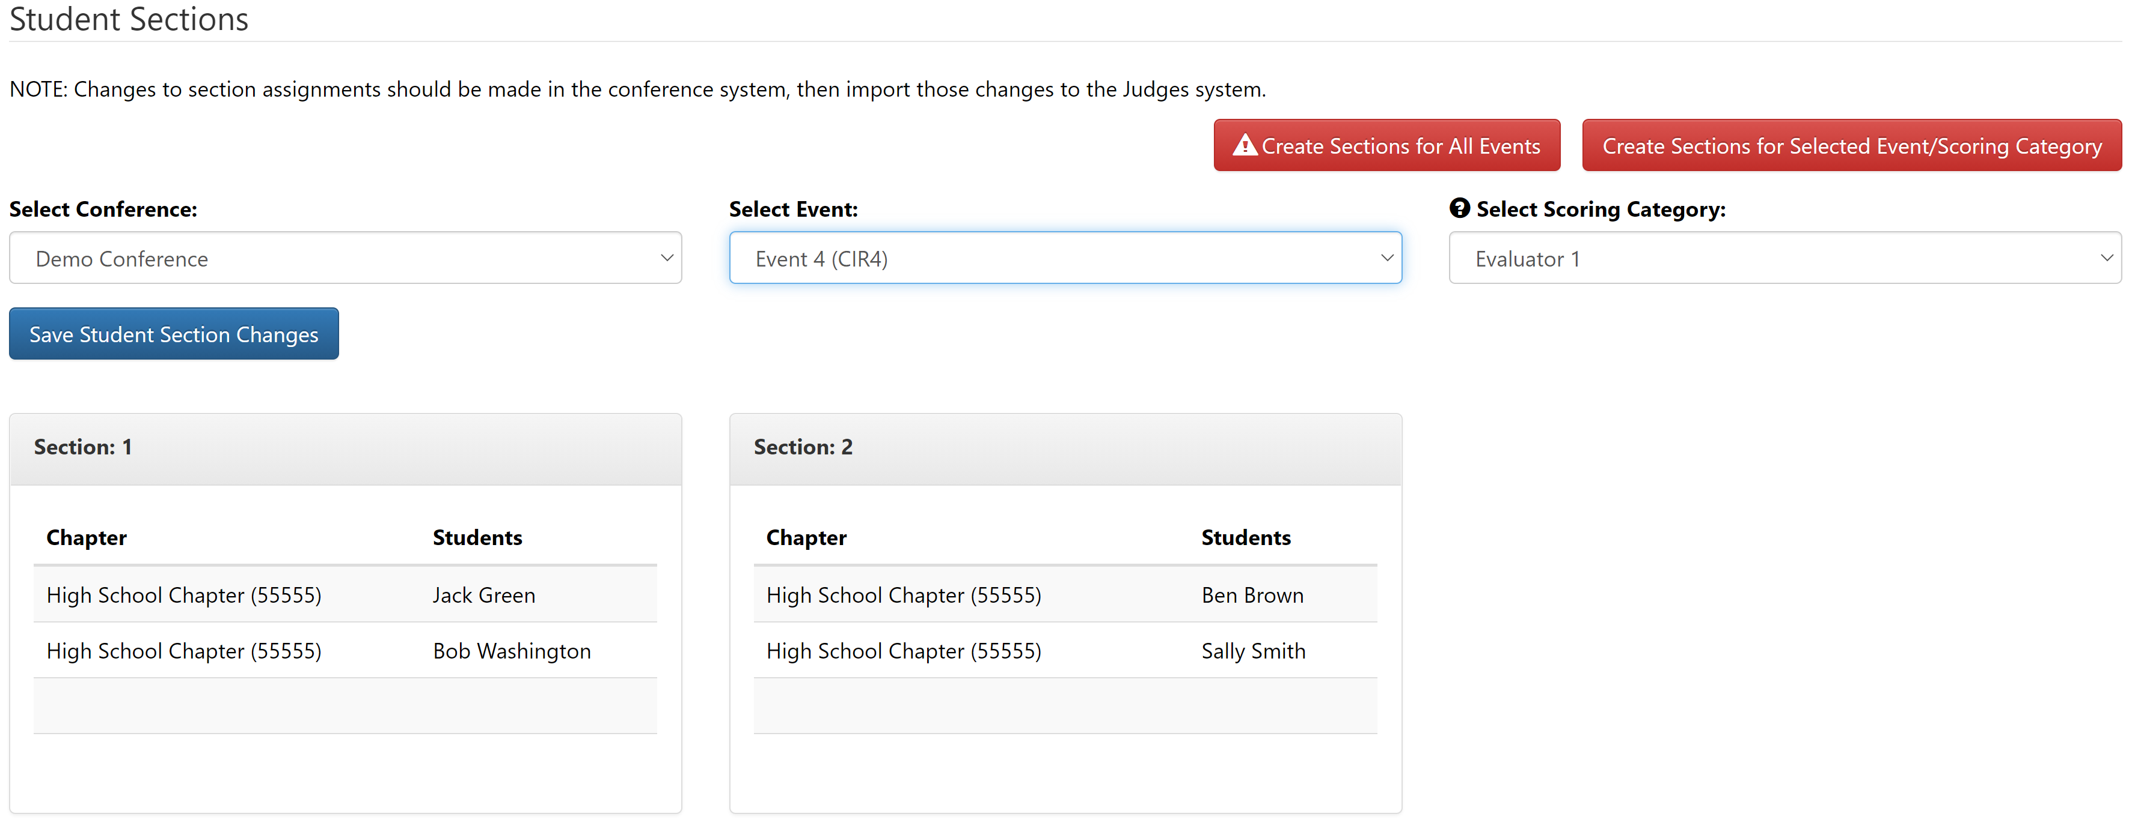
Note: Once you have the student allocated between the sections, you have the option to move the students around in the sections
- Click on the Student Name that you want to move to another section
- Press down and hold the left mouse button and drag the student to the appropriate section and release the left mouse button
- Repeat until you have the students moved to the sections that you want the students to be in
- Click on the “Save Student Section Changes” button

Step 7 – Judge Pro Event Setup and Settings Continued

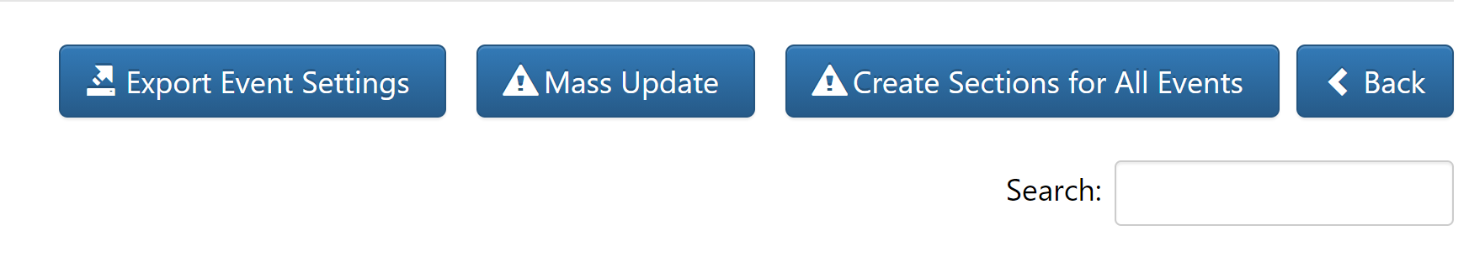
- If you have entered all of your sections for events, you can click on the “Create Sections for All Events” button. This will create sections for ALL events based on the number of sections that you entered into the “#Sections” field

IMPORTANT: If you see Export Event Settings, Mass Update and Create Sections for All buttons at the top right-hand side of the screen, this means that you do NOT have schedules setup in your conference registration system and can use the section option in Judge Pro.
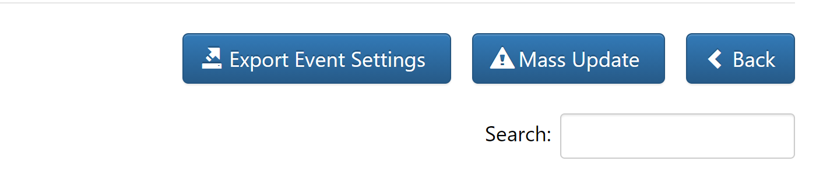
IMPORTANT: If you only see Export Event Settings and Mass Update buttons at the top right-hand side of the screen, this means that your sections are determined by the schedule that is setup in your conference registration system. This means that you will not be able to manually enter sections in Judge Pro because sections are determined by the schedules in your conference registration site.

Step 8 – Judge Management, Judge Import and Judge Event Assignment
Judge Pro Manually Add Judge OPTION
- Click on the “Judges” button
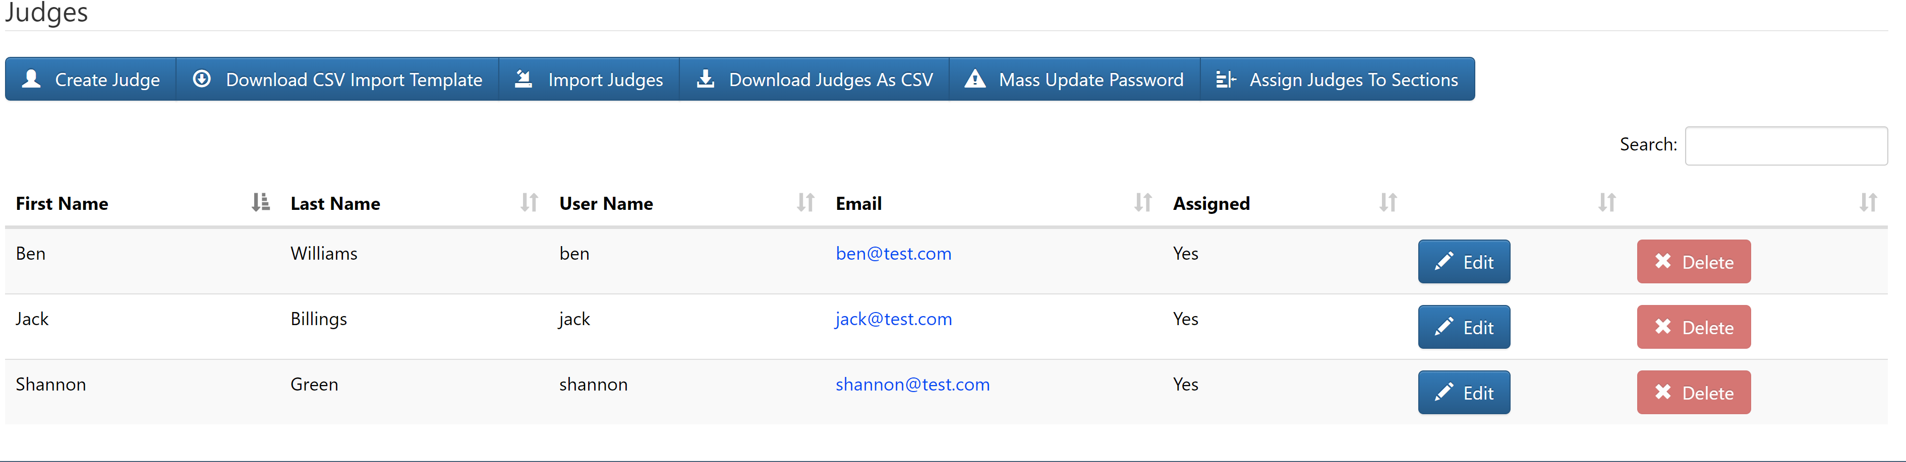
- Click on the “Create Judge” button if you want to manually add a Judge

Step 8 – Judge Management, Judge Import and Judge Event Assignment Continued
Judge Pro Manually Add Judge
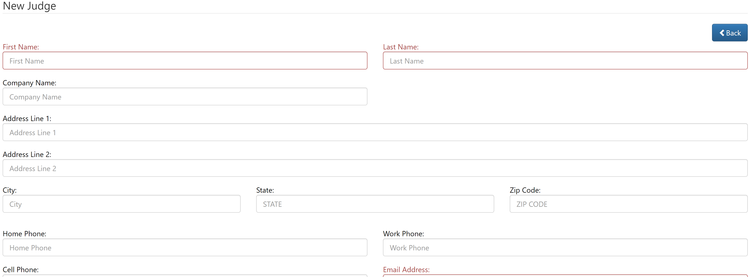

- Complete the “New Judge” form
- Click on the “Save” button

Step 8 – Judge Management, Judge Import and Judge Event Assignment Continued
Judge Pro Import Judges USING INFO FROM THE VOLUNTEER SPREAD SHEET YOU DOWNLOADED AND SAVED ( you can copy from that document the information needed on the template discussed below, or modify you spread sheet to mirror the one discussed below.)
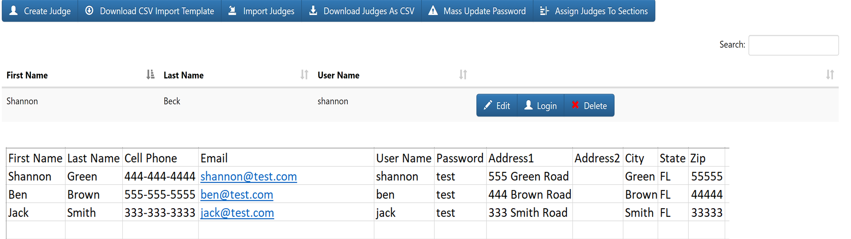
- Click on the “Download CSV Import Template” and download the required template to import judges
- Add Judges to the Downloaded Template
  - Required data fields are First Name, Last Name, Cell Phone, Email, User Name and Password
- Click on the “Import Judges” button
- Click on the “Click Here to Select Files OR Drag Them Here to Upload” button Or Drag the Judge file over the “Click Here to Select Files OR Drag Them Here to Upload” button
- Click on the “Save Judges” button
Download Judges that exist in the Judge Pro system
- Click on the “Download Judges As CSV” button
Mass Update Judges Password
- Click on the “Mass Update Password” button
- Type the “Password” in the “New Password” field Password will be Region#, ie Region3
- Click on the “Update Password” button

Step 8 – Judge Management, Judge Import and Judge Event Assignment Continued
Judge Pro Assign Judges to Events/Sections
- Click on the “Assign Judges to Sections” button
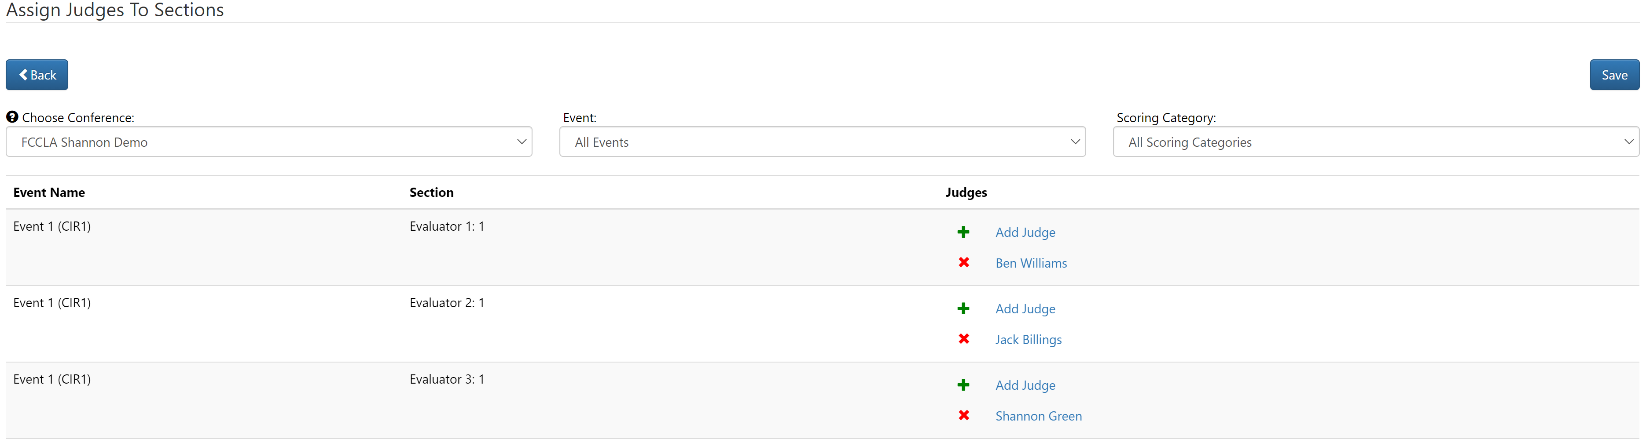
- Click on the “Add Judge” option located on the right-hand side of the Event
- Select the appropriate “Judge” from the Drop-Down list
- Click on the “Confirm” button
- Repeat until you have all your Judges assigned to Events
- Click on the “Save” button
Step 8 – Judge Management, Judge Import and Judge Event Assignment Continued
Judge Pro Mass Email Judges
Note: Once you have imported your Judges, you can email the Judges that are in the system
Note: If you have assigned judges to events, you can insert the mail merge fields into your email (events, judgesloginurl and Username) and it will populate the information that the Judge will need to score the events that the Judge was assigned to. There is no mail merge field for the Judge Password so you will have to type in the global password for Judges in the email.
- Click on “Utilities” button located in the Menu at the top of the page
- Click on the “Mass Email Judges” from the Drop-Down Menu
- Compose the appropriate email for the Judges
- Click on the “Click Here to Select Files or Drag Them Here to Upload” button to add a file to the email
- Click on the “Send” button

