Name: ______________________________

3 Ways I can take care of myself:

1. ____________________
2. ____________________
3. ____________________

3 Ways I can show others that I care:

1. ____________________
2. ____________________
3. ____________________

I accept myself because . . .

________________________________________________________________________________________________________________________________________________________________________________________________________________

I accept others because . . .

________________________________________________________________________________________________________________________________________________________________________________________________________________

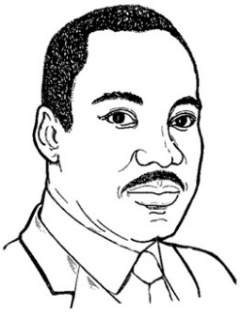

“The time is always right to do what is right.”

* Dr. Martin Luther King Jr.

Name: ______________________________

A time when I was working in a group and our differences made us stronger . . .

________________________________________________________________________________________________________________________________________________________________________________________________________________

________________________________________________________________________________________________________________________________________________________________________________________________________________

A time when I spoke up for what is right . . .

____________________________________________________________________________________________________________________________________________________________

____________________________________________________________________________________________________________________________________________________________

____________________________________________________ ____________________________________________________



Name: ______________________________

A positive change I would like to see in the world is . . .

____________________________________________________________________________________________________________________________________________________________

____________________________________________________________________________________________________________________________________________________________

____________________________________________________ ____________________________________________________

Something I would like to do to make this change is . . .

____________________________________________________________________________________________________________________________________________________________

________________________________________________________________________________________________________

____________________________________________________ ____________________________________________________



Name: ______________________________

Acceptance looks like: _____________________________

Acceptance feels like: ______________________________

Acceptance sounds like: ___________________________

How can I help spread acceptance in my home?

________________________________________________________________________________________________________________________________________________________________________________________________________________

How can I help spread acceptance in my school?

________________________________________________________________________________________________________________________________________________________________________________________________________________

How can I help spread acceptance in my community?

________________________________________________________________________________________________________________________________________________________________________________________________________________

Lesson Plan Outline: FCCLA MLK Day

**Learning Objective:** To spread awareness of diverse perspectives and how MLK Jr.’s ideals connect to everyday life through literature.

**Materials:**

* Handouts being used:
* Book being used:

*Dedicate the start of class to reading aloud a piece of children’s literature that was written by an author with a diverse background or is features messages similar to those of Dr. King.*

*Take some time to ask questions that help relate the content of the book to the next activity.*

*Provide students with the materials you would like them to use.*

|  |  |
| --- | --- |
|  |  |
|  |  |
|  |  |
|  |  |