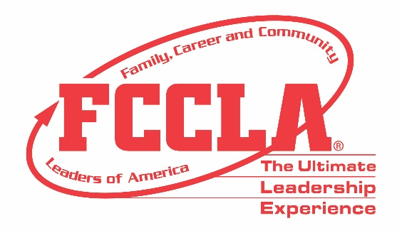
FOR IMMEDIATE RELEASE Contact: Supriya Patel, MN FCCLA Vice President Public Relations
Email: 21spatel@mypanthers.org

Minnesota Family, Career and Community Leaders of America (FCCLA) and the Global Youth Service Day “Each One, Reach One” Campaign

April 17-19th –Youth Service America launches its 32nd annual Global Youth Service Day (GYSD). Formerly known as National Youth Service Day, it is “the largest youth service and civic action event in the world,” and Minnesota Family, Career and Community Leaders of America (FCCLA) is proud to be a Lead State Agency for Global Youth Service Day 2020.

Global Youth Service Day started as National Youth Service Day in 1988. It is coordinated by Youth Service America, and most of the projects are based in the United States. Every year on GYSD, youth organizations, schools and individuals around the world realize thousands of projects. Youth focus on voluntary community service and range from learning sessions about current social and environmental challenges. MN FCCLA is challenging middle and high school members across the state to take on a project during the COVID-19 situation. We want youth leaders to complete an individual or small group project from home to help someone in their community.

Some great projects have come from our State Executive Council about what participants can do from home. State President Amber Findlay did distance learning care packages for teachers. Due to the COVID-19 progression, schools have been closed and distance learning has been introduced to many school districts. Amber said; ”We used FCCLA chapter funds and provided teachers with valuable supplies (pens, pencils, sticky notes, etc.) but also supported small businesses in town.” Another great example was helping the elderly, whom are the most at risk, which came from State Secretary Hailey VonEnde. She says, “In order to help keep my grandparents healthy, and have no need to leave their house, I decided I would visit each of them and get their grocery lists.”

MN FCCLA members earlier also did service projects throughout the year for the 911 Day of Service and Martin Luther King Jr. Day of Service. For 9/11, over 1735 youth volunteers served military persons during the month of September (or on September 11), FCCLA chapters honored military persons, or veterans in their community. For MLK, during the month of January, members planned a service event to deal with financial literacy, or help financial needs of persons in their school or community.

For more information regarding Youth Service America, Global Youth Service Day, and Minnesota FCCLA, contact:
Wendy Ambrose, State Executive Director, wendy.ambrose@mnfccla.org (651) 330-2950
Supriya Patel, Vice President of Public Relations, 21spatel@mypanthers.org
Amber Findlay, President, a.j.findlay123@gmail.com
About FCCLA www.mnfccla.org https://mnfccla.org/programs/global-youth-service-day/
Family, Career and Community Leaders of America (FCCLA) is a dynamic and effective national student organization that helps young men and women become leaders and address important personal, family, work, and societal issues through Family and Consumer Sciences education. FCCLA has over 175,000 members and more than 5,300 chapters from 50 state associations, Puerto Rico, and the Virgin Islands. FCCLA: The Ultimate Leadership Experience is unique among youth organizations because its programs are planned and run by members, and is the only career and technical in-school student organization with a central focus on careers that support families. Participation in national FCCLA programs and chapter activities helps members become strong leaders in their families, careers, and communities. ###

