GLOBAL YOUTH SERVICE DAY 2020
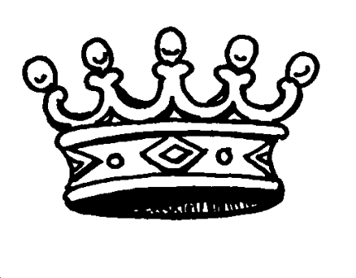 | Triple Crown of MN FCCLA Service!  The Spring Challenge  Global Youth Service Projects: April 17-19, 2020  FCCLA Chapters! Make an impact on spring in your community and on a global community with our onsite service projects.
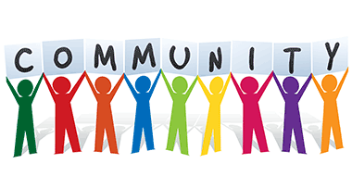
COMMUNITY SPRUCE UP
Community Service
Some ideas:
- Helping elderly with house chores
- Helping food shelves resort
- Helping outdoor projects for parks, homes of elderly in your community.

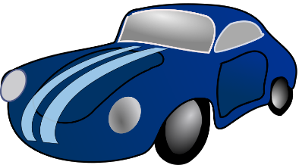SAFE TEEN DRIVING
Healthy Decisions-Student Body, FACTS
Families Acting for Community Traffic Safety
Some ideas:
- Do a school campaign about safe prom night driving
- Do a seat belts save lives project
- Plan a no texting and driving campaign for teens or families
- Promote safe passenger ideas to teens. (Seat Belts, Not distracting activities, etc.

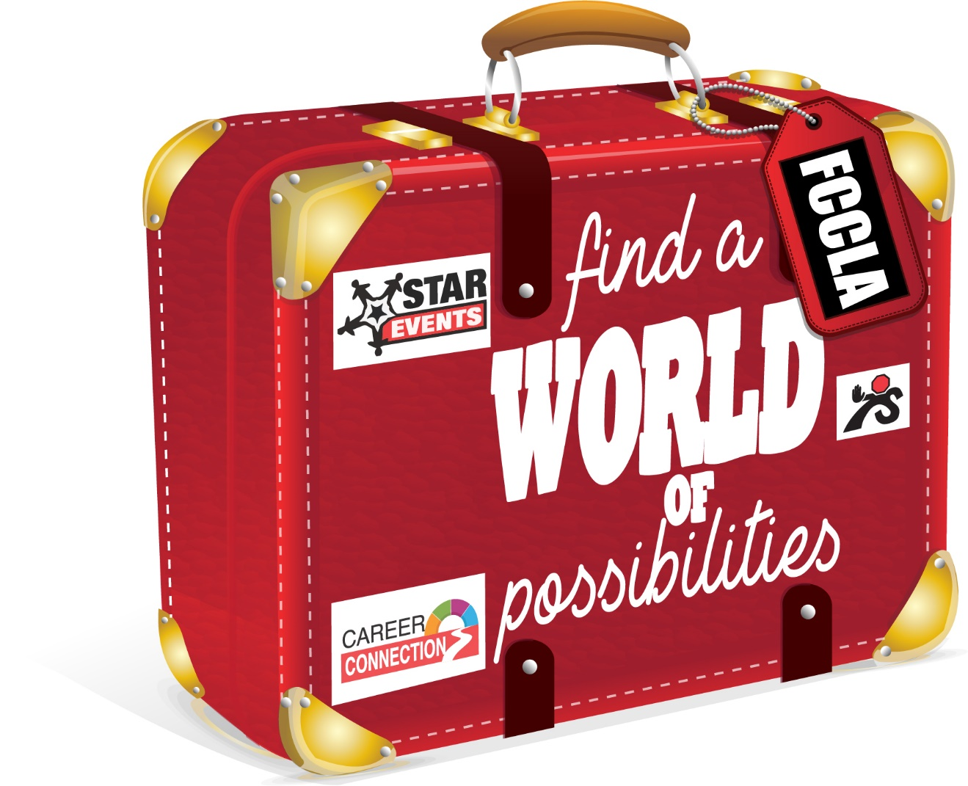
A WORLD OF POSSIBILITIES!
Student Body, Families First, Career Connections, Stop the Violence
Chapters brainstorm about community needs that their youth energy could positively affect. Some Ideas:
- Stop the Violence- Anti Bullying campaigns for younger students.
- Career Connections- Conduct a career fair at your school
- Families First- Help older persons with technology issues, assist them to do an email to extended family members
- Student Body- Healthy food- Do a community garden project, plant seeds for healthy vegetables.
- Student Body- Encourage families and youth to get out and walk with a community walk or night of walks around the school athletic fields.

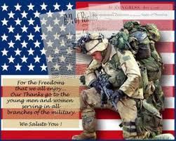
SUPPORT FOR MILITARY
Families First- You-Me -Us
Some ideas:
- Participate in State Conference activities for bracelet making, reaching your chapter’s goal
- Write postcards and send to Operation Gratitude.
- Plan a reception or recognition for military, veterans, first responders in your community.
- Adopt a service person and send them care packages.

