MINNESOTA FCCLA
SHADOW DAY

February 19, 2020
Weather Backup day: March 4

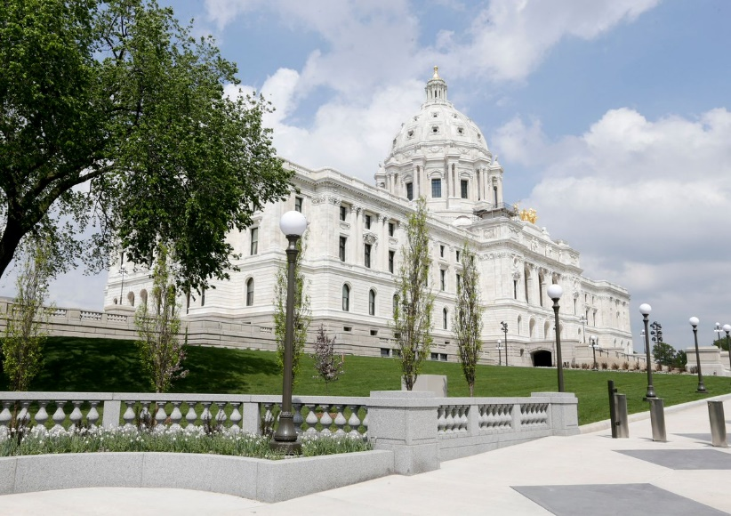
Timeline for the Shadow Application and Experience:

Application deadline: Dec 18, 2019

Notification to you of your application acceptance: Jan 17, 2020

Notification to you of your assigned legislator: Feb 12, 2020

Training and Shadow Day- February 19, 2020
MN DEPT OF EDUCATION, Conference Center Room 13
Address: 1500 Highway 36 West, Roseville, MN 55113

Shadow Day Draft Agenda SUBJECT TO CHANGE

7:00am Registration

9:00 am Legislative Shadow Day Training

11:00 am Lunch on your own

12:30- 3:30pm Shadow Experience

3:45pm Picture on Front Steps

4:00pm Evaluation and Thank You notes done-before you leave

Minnesota Association of Family, Career and Community Leaders of America

Application for Shadow Day Experience- February 19, 2020
Application Deadline: Received December 18, 2019 by 4 pm.

Make check payable to MN FCCLA, PO Box 131386, Roseville, MN 55113

Participant Registration: Cost $25.00-
Participant Name: ___________________________________________________________________________
Chapter Name: _____________________________________________________________________________
Participant Home Address: ___________________________________________________________________
Current Grade: _________ Zip Code: ________Cell Phone Number: ________________

Participant Email Address: ____________________________________________________________________

Adult/ Adviser Registration: Cost $25.00-
(Note: All participants must attend with a chaperone (adviser, school faculty, parent or other as determined by the local school district)
Name of Adviser/ Adult attending: ____________________________________________________
Adviser/ Adult Email Address: _______________________________________________________
Adviser Cell Phone: _____________________________

IMPORTANT NOTE: If you are selected and do not attend or cancel, it could result in ineligibility of competing in MN FCCLA STAR Events. We must have you follow through with this commitment.
- Arrival
_____We will be arriving the night of Feb 18.
_____We will be arriving the morning of February 19, 2020
Note: The shadowing component of this event will be with members of the Education Committees of the House and Senate:

- Do you currently know a legislator personally? _____No _____Yes
If Yes, whom? ________________________________

- Who are your local legislators?
Local Senator: ____________________________________
Local Representative name ________________________
- Participant Membership Information: Number of years in FCCLA _____ Grade Point Average: _____
- Please list all Family and Consumer Science Classes you have taken.

- How many MN FCCLA State Conferences have you attended?

- How many National FCCLA Conference have you attended? Please list the locations.

- Have you participated in any FCCLA STAR Events? If so which, ones?

- Please write a 4 sentence summary of yourself including your age, grade, interest in Shadow day and experiences in FCCLA. (This may be shared by MN FCCLA with legislators to request you would shadow them)

- Please tell us in 50 words or less what your favorite National FCCLA Program is and why it important for students.

- Please tell us in 100 words or less what kind of chapter projects have you helped out with and how did it make a difference in your community.

- Please list any other student organizations, sports or other activities are you involved in.

- If chosen for this event it is likely that you will be asked many questions regarding Family, Career and Community Leaders of America.
If someone were to ask you why FCCLA is hosting a shadowing project what would you say? If someone asked you your opinion about the importance of Family and Consumer Science education, how would you respond?

- What do you hope to learn from this Shadow Day Experience?

Signatures
If chosen for this program you are expected to participate in all parts of the Shadowing Project.

By signing this application, you agree to follow the FCCLA Conduct Code, participate in the project on February 19^{h}, and fulfill the follow-up activities to publicize your experiences to your chapter, school and/ or community.
You also agree to make arrangements with your local school administration/ faculty for any missed work during your absence.

_________________________________________________Signature of Participant

We support the applicant for participation in the Legislative Shadowing Project.

__________________________________ _________________
Adviser Signature Date

__________________________________ _________________
Administrator Signature Date

__________________________________ _________________
Parent/ Guardian Signature Date

