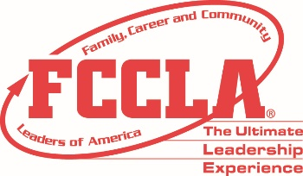 MN FCCLA PARTICIPANT SIGN IN SHEET
9/11 Day of Service Sign-In Sheet
The 2019 goal of 9-11 Day of Service is to serve Military, Veterans or Military families.
IMPORTANT By Sept 12- Return report forms to MN FCCLA via email (wendy.ambrose@mnfccla.org)
Re: 9-11 report or as a document in the link for the survey report.
Chapter or School Name: ______________________Adviser:_______________________
Site location of service project: _____________________________
Date:________ Time start:______ Time end :______
Purpose of project:__________________________________________
Did any elected officials or other VIPs attend?_______________________
Did your project receive media coverage? ____________ describe
Did you post on social media? ______add social media handles:________
Describe the results of your project: _____# items sent, # people served.
 | Date | Name (Please Print)  *Each participant must sign their own name* | Age or grade | Time In | Time Out | Check if  Adult | Check if Student
Use more pages if needed.

