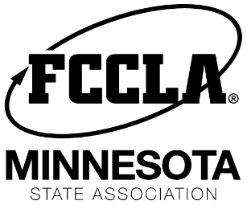
MN FCCLA Chapter “Spark” Award
The Chapter “Spark” Award is rewarded to one member in each chapter that exhibits the most enthusiasm, excitement, and positive attitude for FCCLA in their chapter.
This member:
- demonstrates enthusiastic participation in all activities,
- offers encouragement to other members,
- lights the way for his/her peers,
- strives to find the positive in any situation.
Nomination:
- Nominated by advisor
- One per chapter
Chapter Spark Nominees will be submitted with the State Conference Registration.

Advisers may submit one nominee. There is not evaluation of the Adviser’s nomination, whoever the Adviser nominates will be recognized for this award.

Award:
- Certificate
- Recognition on stage at State Conference
- Featured in MN FCCLA communications.

Deadline to submit nominations is State Conference Deadline: Feb 12, 2020
when the Chapter Registration for State Conference is completed.

