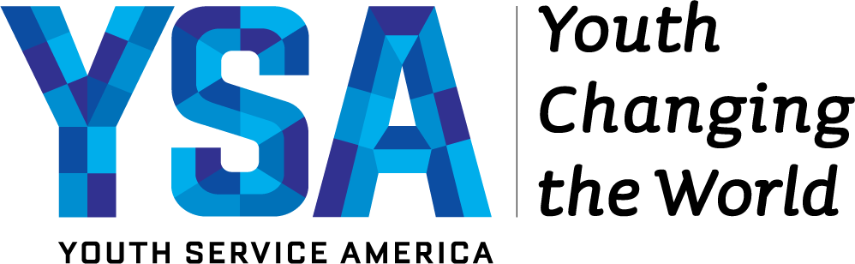
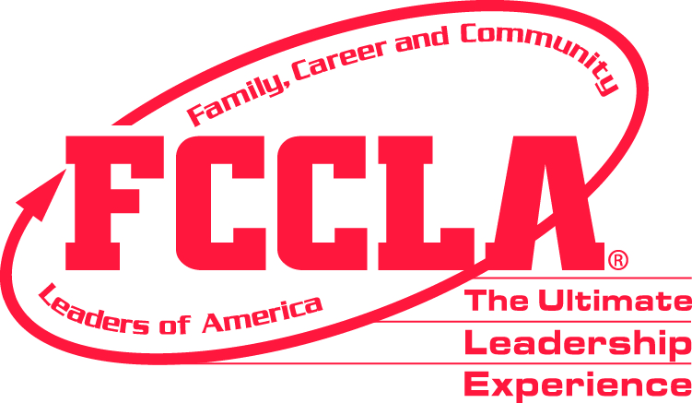

For Immediate Release
August 2019

Minnesota Family, Career and Community Leaders (FCCLA) Designated as Lead Agency to Engage Youth on National Days of Service in Minnesota

Roseville, MN — Minnesota Family, Career and Community Leaders of America (FCCLA) will serve as a Youth Service America Lead Agency, mobilizing Minnesota young people to lead volunteer service projects that help meet community needs on 9/11 Day of Service & Remembrance (September 11, 2019), MLK Day of Service (January 20, 2020), and Global Youth Service Day (April 17-19, 2020). These three days are officially designated as National Days of Service by the 2009 Serve America Act.

With grant funding from The Charles Stewart Mott Foundation and the Corporation for National and Community Service along with training and support from YSA (Youth Service America), MN FCCLA will build a culture in which all young people in Minnesota have the opportunity and support to find their voice, take action, and make an impact in their communities. As the official local organizers for these national days of service, Lead Agencies are a vital part of YSA’s work to activate all youth, ages 5-25 - especially those in under-served communities who aren’t usually asked to participate.

MN FCCLA will engage at least 1500 youth volunteers, and partner with 10 other community-based organizations and schools, including MN FCCLA chapters and schools where FCCLA is active, other organizations and food shelves throughout Minnesota. Guided by their young people, MN FCCLA and its coalition partners will organize large-scale community events, celebrations and community service projects on Global Youth Service Day.
The State Officers of FCCLA have challenged MN FCCLA members to seek to do a “Triple Crown” participation of engaging in all three service days in 2019-2020 school year.

“We are thrilled to partner with Minnesota FCCLA and the thousands of young people who will serve and celebrate on these days of service,” said Steven A. Culbertson, President and CEO of YSA. “We’re currently leaving two-thirds of our young citizens out of actively participating in our democracy. Volunteering is a gateway to a lifetime of civic participation and days of service are on-ramps to volunteering, especially for first-time volunteers.”

“MN FCCLA is excited to take a leadership role to serve Minnesota communities, schools and see youth leaders learn valuable leadership and employability skills by working together on various service projects through this school year.” Says Wendy Ambrose- Executive Director, MN FCCLA.
###

Minnesota Family, Career and Community Leaders of America (FCCLA) is a dynamic and effective student organization that helps young men and women become leaders and address important personal, family, work and societal issues through career and technical education and family and consumer sciences education. www.mnfccla.org.

YSA (Youth Service America) believes that youth, communities, and democracy thrive when we all work together for the common good. YSA is a leading global nonprofit that activates young people, ages 5-25, to find their voice, take action, and acquire powerful civic and 21st Century skills as they solve problems facing their communities. YSA supports its activation campaigns – including 9/11 Day of Service, MLK Day of Service, and Global Youth Service Day - with grants, training & resources, and recognition programs for young people and their adult champions. Youth-led projects use Awareness, Service, Advocacy, and Philanthropy (ASAP) strategies to create social and environment change. For more information, visit www.YSA.org.

Honoring the history of September 11th by serving in your community helps transform 9/11 into a day of unity, empathy, and service as an enduring and positive tribute to those lost and injured on 9/11/01, and the many who rose in service in response to the attacks, including first responders, recovery workers, volunteers and members of our military. www.YSA.org/911Day

Martin Luther King, Jr. Day of Service is Monday, January 21, 2019. It is the only federal holiday observed as a national day of service – a “day on, not a day off” – and is an opportunity for people from all walks of life to work together to help solve our most pressing problems. The MLK Day of Service empowers individuals, bridges barriers, and moves us closer to Dr. King’s vision of a “Beloved Community.”www.YSA.org/MLKDay

Celebrating 32 years of youth changing the world, Global Youth Service Day (GYSD) is the largest youth service and civic action event in the world and the only one that celebrates and creates opportunities for all youth ages 5-25, their communities, and our democracy to thrive by working together for the common good. www.GYSD.org

Media Information
Wendy Ambrose Executive Director
651-330-2950 wendy.ambrose@mnfccla.org
#mnfccla
www.mnfccla.org

Katie Reusch, Director of Partnerships
YSA (Youth Service America)
kreusch@ysa.org | (202) 650-5056
T: @YouthService | I: @YouthService | F: @YouthServiceAmerica

