FCCLA LEADERSHIP
CAMP 2019
With Leadership Training by dynamic trainers

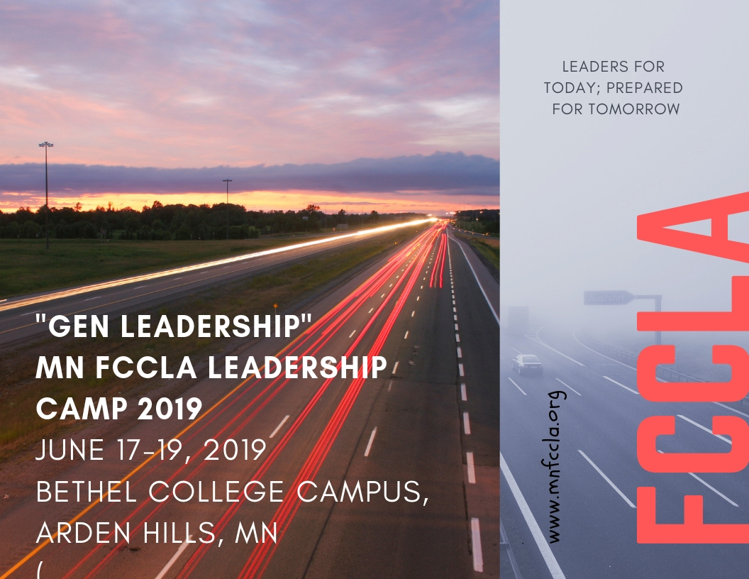
2019 FCCLA Leadership Camp
Registration-Due May 1
Name:_______________________________________________Chapter:________________________
Check one: ____Chapter Leader ____State Officer
____Area Officer ____ JHC ____National Officer/ candidate ____Guest
____Area Peer Ed _____Potential Adviser ____Adviser ____Chaperone
Home Address: _______________________________________________________________ ___Male ___Female
Town____________________Zipcode_________________ Phone (______)-____________________Grade:_______
Cell phone (______)-_________________E mail (summer)____________________________________
Do you need special meal considerations?: ___________Yes.. Describe the need:__________________________
Camp attire: Khaki or black slacks or Capri length. FCCLA polo shirt, white, red or black shirt or FCCLA t shirts
FCCLA Camp Registration | Description |  | Amount |  | Total
Exec Council plus Leadership Camp
State Officers-Registration fee and lodging/ meals BRING LINENS. TOWELS | June 15 (Friday evening) through June 20 morning. |  | $290.00 paid by FCCLA |  | 0
State Officers Advisors-Registration fee and lodging/ meals Due May 1 Double rooms BRING LINENS.TOWELS | June 15 (Friday evening) through June 20 morning. |  | Double room |  | $310.00
State Officers Advisors Registration fee and lodging/ meals Due May 1-Double rooms BRING LINENS.TOWELS | June 15 (Friday evening) through June 20 morning |  | Single room |  | $355.00
Leadership Camp-Monday, Tuesday and Wednesday morning
Chapter leaders Registration fee and lodging/ meals Double rooms BRING AND LINENS. TOWELS | June 17, 18, 19 Monday Tuesday and Wednesday through the afternoon. |  | $165.00 |  | $165.00
Officers, JHC Registration fee and lodging/ meals Due May 1-Double rooms BRING LINENS. TOWELS | June 17, 18, 19 Monday Tuesday and Wednesday through the afternoon. |  | $165.00 of which the Region funds can pay ½ |  | $82.50 from region funds $82.50 from  officer
Peer Ed Registration fee and lodging/ meals Due May 1-Double rooms BRING LINENS. TOWELS | June 17, 18, 19 Monday Tuesday and Wednesday through the afternoon.. |  | $165.00  of which the Region funds can pay ½ |  | $82.50 from region funds $82.50 from  officer
Advisors of Officers, JHC, Peer Ed, chapter leaders Registration fee and lodging/ meals Due May 1-Double rooms BRING LINENS. TOWELS | June 17, 18, 19 Monday Tuesday and Wednesday through the afternoon. |  | Double room |  | $115.00
Advisors of Officers, JHC, Peer Ed, chapter leaders Registration fee and lodging/ meals -Double rooms BRING LINENS. TOWELS | June 17, 18, 19 Monday Tuesday and Wednesday through the afternoon.. |  | Single room  (As available-First come, first served) |  | $190.00
Late fee After May 1 Add $15.00 | Received after May 1 |  | Add $15.00 |  | Add $15
Late Fee- After May 10 Add $35.00 | Received after May 10 |  | Add $35.00 |  | Add $35
STAR EVENT HELP SESSION  No meals, no overnight | June 18, 2019  9 am-noon |  | No meals, no overnight |  | $10.00
Add official red jacket rental fee  OFFICER ANNUAL JACKET RENTAL FEE $ 25.00 (Chapter may pay this fee)  Women’s size needed_____ Men’s Size needed______ |  |  |  |  | Officer Jacket fee $25.00
STAR Event Youth NLC Delegate-Jacket rental for National Conference ($10 for 1 week rental plus shipping $12.00) |  | Men’s Size needed______  Women’s size needed______ |  |  | $22.00 one week jacket plus shipping
STAR Event Youth NLC Delegate Jacket rental for National Conference ($10.00 for 1 week) pick up at camp- no shipping. |  | Men’s Size needed______  Women’s size needed______ |  |  | $10.00 one week jacket no shipping
Mail to: MN FCCLA, MN FCCLA, PO 131386, Roseville, MN 55113. |  |  |  | Total  $

, code of conduct and check
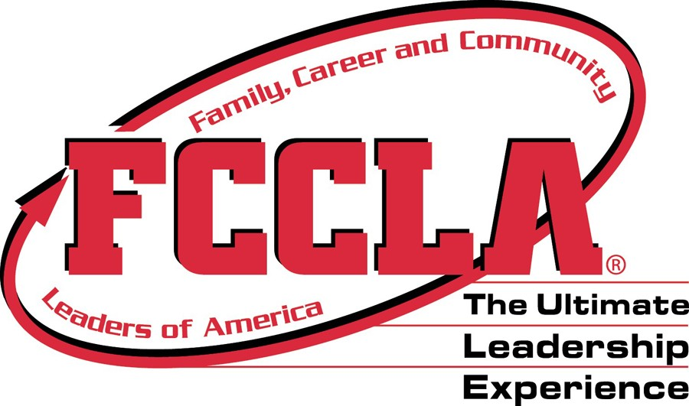
Health Form MN FCCLA
FCCLA Camp-Dynamic Leadership I
Directions: Please complete and sign this form and return a copy to your advisor and a copy to the state FCCLA office with registration

Students name:___________________
Date of Birth:____________________
Home Address:___________________
City, State , Zip:___________________
Phone:(Home)____________________
Work___________________________
Cell:____________________________
School name:_____________________
Family Physician:__________________
Physician phone number:____________
Is student presently under medical care or taking a prescribed medication? ____Yes ____No
If yes, describe the medication/s:

Is student allergic to any medication?
____Yes____No If yes -list medication/s.

Does your son/ daughter have any health problems? e. g. Diabetes, pregnancy, seizures, allergies?
____Yes ____No
If yes- please describe any special care that is needed.

*******************************************
Parent/ Guardian Name: ________________
Parent Address:_______________________
City/ State/ Zip:
Phone: Home_________________________
Work:_______________________________
Medical Insurance:
Name of company:______________________
Name of insured:_______________________
Policy number:_________________________
Insured ID Number:____________________

I, _____________________________________, (name of parent /guardian)( relationship to student)
authorize in advance any necessary medical treatment as required in the judgment of the attending physician while the student is absent from home and attending an FCCLA event.

Even though your son/ daughter may be 18 years of age, he/she will be subject to the rules of the conference (according to the age of majority, distributed by the Minnesota Dept of Education and the Attorney Generals’ office) he/ she will not be allowed to possess or drink alcoholic beverages, possess or use non prescription drugs or
smoke/chew tobacco.

Will you support your son/ daughter/s advisor and the FCCLA Executive Director in enforcing these rules?___Yes ___No

Infringement upon these regulations requires that the student will be sent home from the conference at your expenses. Will you see to it that your son/ daughter is picked up at the conference if such a procedure becomes necessary?
___Yes ___No
Signature:___________________________________
Date:_________________________

In Case of Emergency Call:
Name of first choice______________________

Work phone (______)________________________
Home Phone (______)________________________
Cell phone (______)_________________________

Name of second choice________________________
Work phone (______)________________________
Home Phone (______) ___________________________________________
Cell phone (______)_________________________.
Mail Registration, health form, and check to: MN FCCLA PO 131386, Roseville, MN 55113

Parent/Guardian Permission Form
Student name
First name Last name
 | Advisor name Cell phone of student
 |  |  |  |  |  |  |  |  |  |  |  |  |  |  |  | - |  |  |  | -
 | Chapter Phone of Advisor (Cell phone #preferred)
 |  |  |  |  |  |  |  |  |  |  |  |  |  |  |  | - |  |  |  | -
Directions: This form is to be returned to the LOCAL ADVISOR and used by the local advisor.
ADVISORS: Keep a copy and bring a copy of these forms for the state conference registration files.
The Minnesota Association of the Family, Career, Community Leaders of America will hold Leadership Training June 17-19 2019 at Bethel College, Arden Hills, MN. Please fill out the questions below if your daughter or son is to be one of the representatives to this training. Forms must be returned before your delegate may attend.
**Transportation for camper will be provided by:____________________________________________(to arrive)
***Transportation home will be provided by:_______________________________________________( to leave)
- Do you approve of your son or daughter attending the State FCCLA Training to be held at the Bethel College. | YES | NO
- Do you approve of your son or daughter participating in leadership activities? | YES | NO
- Do you know the plans for the trip, including who will chaperone the group, the mode of travel? Do you approve of these plans? | YES | NO
- Do you expect your son or daughter to see or call relatives or friends while en route to or in Roseville? If yes, please write the name and address of relative and/or friend: _____________________________________________ | YES | NO
- Do you plan for your son or daughter to leave the group at any time while traveling to or in Roseville? If yes, please explain: ___________________________________________________________ | YES | NO
- Does your son or daughter agree to abide by the rules of no use or possession of alcohol, drugs or cigarettes as well as the camp curfew? | YES | NO
- Does your son or daughter give permission to use likeness in a photograph or other digital reproduction in any and all of its publications, including website entries, without payment or any other consideration. I further give permission to MN FCCLA to share this image with its partners for use in any and all of its publications, including website entries, without payment or other consideration. I understand and agree that these materials will become the property of Minnesota FCCLA and will not be returned. | YES | NO
VIOLATION OF THESE RULES WILL RESULT IN THE PARENT COMING TO LEADERSHIP CAMP TO GET THE STUDENT OR FINANCING TRANSPORTATION HOME IMMEDIATELY.
Name two persons who may be contacted in case of an emergency
- Name Phone
- Name Phone
Explain any special care needed:
_____________________________________________________________________________
By signing this, I agree to the terms stated above.
- Signature of Parent: ____________________________________Date:________________
- Signature of Delegate: _________________________________Date: ________________
- ADVISORS: Keep a copy and send a copy of these forms.

2019 FCCLA Leadership Training -Delegate Code of Conduct--Make 2 copies
Please return a copy of this signed code of conduct to your chapter advisor.
The advisor should bring the copies of the code of conduct to hand in at registration or send it with the registration and also keep one copy for your own use.

Name:_____________________________________ Chapter:____________________________

I realize that attending Dynamic Leadership Training is a responsibility and an opportunity to attend one of the finest youth events in the state. As a delegate from my chapter, a representative of my school and community,

I agree to act in a professional manner.
____ Yes, I agree to attend all sessions for delegates and take full advantage of the training.
____ Yes, I agree to attend all sessions and be respectful of the speaker, presenters and fellow delegates
____ Yes, I will promote and demonstrate the positive image of a positive youth leader.
____ Yes, I will refrain from the use or possession of alcohol, drugs or tobacco during the training.

____ Yes, I agree to abide by all rules of conduct set by the State Association and the rules set by my FCCLA chapter advisor and chaperones.

____ Yes, I will be respectful of campus property and the property of other delegates and roommates.

____ Yes, I hereby grant Minnesota Association of Family, Career and Community Leaders of America permission to use my likeness in a photograph or other digital reproduction in any and all of its publications, including website entries, without payment or any other consideration. I further give permission to MN FCCLA to share this image with its partners for use in any and all of its publications, including website entries, without payment or other consideration. I understand and agree that these materials will become the property of Minnesota FCCLA and will not be returned.

____ Yes, I realize that the state association has a new Board of Directors policy for posting videos and other technology of myself or members: You-tube videos shall be approved by MN FCCLA if they: 1) Video or audio was taken at an FCCLA event. 2) Show or identify FCCLA on shirts, in the audio or background of a video. In order to protect the reputation and quality of FCCLA videos and notices, a policy for members is posted on the website and in the state conference material.

You Tube videos that are approved by the State FCCLA association may be given permission to be posted. Members who post videos identifying Minnesota FCCLA shall be contacted and asked to remove them if they have not been approved with the consent of MN FCCLA. The advisor and /or principal will be notified if they are not removed

Signed: ______________________________________________________ Member

Signed: ______________________________________________________ Parent

Signed:_______________________________________________________Chapter advisor

2019 MN FCCLA Leadership Camp Draft Agenda

Monday- June 17, 2019
Leadership training- with invited trainer
STUDENTS ADVISORS
Registration 11:30am-1:00pm Registration 11:30am-1:00pm
Leadership Training 1:00pm-2:00pm Leadership Training 1:00pm-2:00pm
Leadership Training 2:00pm-5:30pm Leadership Training 2:00pm-5:30pm
Dinner 5:30pm-6:30pm Dinner 5:30pm-6:30pm
Leadership Training 6:30pm-8:30pm Leadership Training 6:30pm-8:30pm
Leadership Training 8:30pm-10:30pm Leadership Training 8:30pm-10:30pm
Curfew 11:30pm Curfew 11:30pm

Tuesday- June 18, 2019
STAR EVENT DEMO AND IMPROVEMENT DAY
STUDENTS ADVISORS
Breakfast 7:00am- 8:00am Breakfast 7:00am- 8:00am
Morning Session 8:00am- 9:00am Morning Session 8:00am- 9:00am
STAR round tables 9:00am- 12:00pm STAR round tables 9:00am- 12:00pm
Lunch 12:00pm- 1:00pm Lunch 12:00pm- 1:00pm
Camp Activity 1:00pm- 3:00pm Camp Activity 1:00pm- 3:00pm
Officer Team Training 3:00pm- 4:00pm Officer Team Training 3:00pm- 4:00pm
Speaker 4:00pm- 5:30pm Speaker 4:00pm- 5:30pm
Dinner 5:30pm- 6:30pm Dinner 5:30pm- 6:30pm
State Officer Round Tables 6:30pm- 8:30pm Advisor Resource Work 6:30pm- 10:00pm
Lip Sync Prep Time 8:30pm- 10:00pm Lip Sync Presentations 10:00pm- 11:30pm
Lip Sync Presentations 10:00pm- 11:30pm
Curfew 11:30pm Curfew 11:30pm

Wednesday- June 19, 2019

STUDENTS ADVISORS
Breakfast 7:00am- 8:00am Breakfast 7:00am- 8:00am
Morning Session 8:00am- 8:30am Morning Session 8:00am- 8:30am
Speaker 8:30am- 9:00am Speaker 8:30am- 9:00am
Area Planning Time 9:00am- 12:00pm Area Planning Time 9:00am- 12:00pm
Lunch 12:00-1:00 pm Lunch 12:00-1:00 pm
Leadership Conf. planning 1:00-2:00 pm Leadership Conf. planning 1:00-2:00 pm
Closing Session 2:00pm- 2:30pm Closing Session 2:00pm- 2:30pm
Area Check in Time 2:30-3:00 pm Area Check in Time 2:30-3:00 pm

