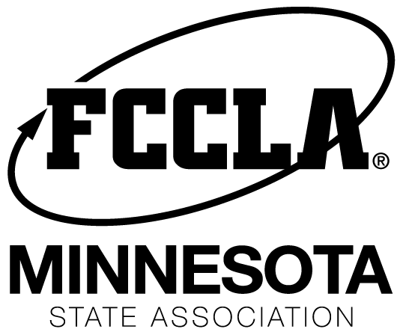

MN FCCLA New Member Award-Due February 13, 2019.

What:
The new member award is developed for the member who has given to your local chapter through their involvement in their first year of participation as a member of FCCLA. (One award per chapter will be selected if the adviser submits more than one applicant.)

Eligibility:
- Nominated by the adviser for this award.
- The new member who has made a significant contribution to the chapter.
- An adviser may nominate more than one member for this award however they should have made a significant contribution to the success of the chapter.
- A new affiliated FCCLA member is eligible to receive the new member award.

Award:
Members submitted for the new member award will receive an official certificate with the with the nominee’s name on it, name in the program, and featured in communications.
The adviser will nominate a new member for this award on the registration online process for state conference. The deadline for state conference registration is February 13, 2019.

