Part 2
STATE CONFERENCE FORMS
2019 STATE FCCLA CONFERENCE
FORMS

- Registration is done on an online web portal system.

ON LINE REGISTRATION WILL INCLUDE:
- STAR EVENT participants will be pre registered based on Areas Midwinter entries
- State Events will be pre registered based on Areas Midwinter Entries
- SKILL Events- WILL BE REGISTERED AT THIS TIME
- CANDIDATES- These will be indicated on your registration for scheduling. (TEST, INTERVIEW or SPEECH) as appropriate for each type of candidate.
- WORKSHOPS- These will be ticketed by Grades. Please sign up your delegates by grades.
- TALENT additional entries accepted in addition to Midwinter entries advancing.
- DANCE SHOWCASE-entries accepted
- LIP SYNC- Sign these up on the registration. No Area level qualification needed. Indicate the song.

- Invoices will be created with the registration process.
Registration covers the costs of the hotel space, programs, security, speakers, supplies, and delegate items.
- Your hotel designation must show you are registered at a conference hotel to avoid a surcharge for unused room blocks. (As part of our contracts to get the space, FCCLA has agreed to use hotel rooms or pay a fee for unrealized revenue that the hotel would not be receiving)
4. Contact the state office and the hotel prior to the conference with names of individuals with disabilities requiring special assistance by March 1.
5. Register one adult chaperone for every 8 students that attend. All chaperones must be registered for the conference.
6. Checks are to be made payable to MN FCCLA. Send to PO 131386, Roseville, MN 55113.

SENT BY HARD COPY TO THE STATE OFFICE:
Forms that need to be sent by hard copy prior to the conference are:
Form A-Parent Permit Form Send these forms to: MN FCCLA *PO 131386* Roseville, MN 55113-0012
Form B-Delegate Code of Conduct Agreement Send these forms to: MN FCCLA *PO 131386* Roseville, MN 55113-0012

ADDITIONAL INFORMATION WE COLLECT VIA VARIOUS METHODS:
Form C-Silent Auction details of your contribution to State Officer Adviser Michele Lindquist at (Kasson-Mantorville High School, by February 23

Form D- Service Parade Entries Enter names in the online registration.

Form E-Student Evaluators- Enter names in the online registration. Students must be grades 10-12 and experienced in STAR Events. Submit additional Evaluators to State Officer Adviser Lori Henry, (Spring Lake Park High School)

Registration deadlines:
Web portal will be open from through February 13.
After February 6- A first late fee will be in effect
After February 13-A second
Registration is closed at 5:30 pm.
Shirt sizes must be submitted in order to be ordered. Incomplete or late registrations may not receive all of the conference supplies.

2019 State Conference: Chapter name:_____________________

Attach additional sheets if necessary,
Send form to: FCCLA State Office, PO Box 131386, Roseville, MN 55113-0012 Postmarked by February 23.
Students-Return form to your Adviser. Advisers - Send form for each student.
Parent/Guardian Permission Form Form A
Student First name Last name
Chapter name Student’s Cell phone
 |  |  |  |  |  |  |  |  |  |  |  |  |  |  | - |  |  |  | -
Adviser name…………………………………. .Adviser cell phone
 |  |  |  |  |  |  |  |  |  |  |  |  |  |  | - |  |  |  | -
Directions: This form is to be returned to the LOCAL ADVISER and used by the local Adviser.
ADVISERS: Keep a copy and bring a copy of these forms for the state conference registration files.
The Minnesota Association of the Family, Career, Community Leaders of America will hold the annual state conference at the Doubletree Hotel in Bloomington, MN on March 28-30, 2019
- Please fill out the questions below if your daughter or son is to be one of the representatives to this conference.
- Forms must be returned before your delegate may attend the conference.
- Do you approve of your son or daughter attending the State FCCLA Conference to be held at the Doubletree Hotel in Bloomington, MN March 28-30, 2019 | YES | NO
- Do you approve of your son or daughter participating in optional fitness activities? | YES | NO
- Do you know the plans for the trip, including who will chaperone the group, the mode of travel, where the group will stay and any plans for sightseeing? | YES | NO
- Do you approve of these plans? | YES | NO
- Do you expect your son or daughter to see or call relatives or friends while travelling to or in Bloomington? If yes, please write the name and address of relative and/or friend: _____________________________________________ | YES | NO
- Do you plan for your son or daughter to leave the group at any time while traveling to or in Bloomington? If yes, please explain: ___________________________________________________________ | YES | NO
- Does your son or daughter agree to abide by the rules of no use or possession of alcohol, drugs or cigarettes including vaping and also abide by the state conference curfew? | YES | NO
- Does your son or daughter give permission to use likeness in a photograph or other digital reproduction in any and all of its publications, including website entries, without payment or any other consideration. I further give permission to MN FCCLA to share this image with its partners for use in any and all of its publications, including website entries, without payment or other consideration. I understand and agree that these materials will become the property of Minnesota FCCLA and will not be return | YES | NO
- We give consent for FCCLA State Association to have knowledge of hotel reservations and the hotels may provide FCCLA information regarding the attendee’s reservation information to facilitate housing. | YES | NO
VIOLATION OF THE CODE OF CONDUCT WILL RESULT IN THE PARENT COMING TO BLOOMINGTON TO GET THE STUDENT OR FINANCING TRANSPORTATION HOME IMMEDIATELY.
Please Name two persons who may be contacted in case of an emergency
Name Phone
Name Phone
Explain any special care needed:

By signing this, I agree to the terms stated above.
- Signature of Parent: ____________________________________Date:________________

- Signature of Delegate: _________________________________Date: ________________
ADVISERS: Keep a copy and send a copy of these forms for the State Conference registration files.

2019 State FCCLA Conf. Delegate Code of Conduct-Make 2 copies FORM B

Please return a copy of this signed code of conduct to your chapter Adviser.
The Adviser should bring the copies of the code of conduct to hand in at registration or send it with the registration and also keep one copy for your own use at the State Conference.

Name:_____________________________________ Chapter:____________________________

I realize that attending a State FCCLA Conference is a responsibility and an opportunity to attend one of the finest youth events in the state. As a delegate from my chapter, a representative of my school and community, I agree to act in a professional manner.

____ Yes, I agree to attend all sessions for delegates and take full advantage of the training.

____ Yes, I agree to attend all General Sessions and be respectful of the speaker, presenters
and fellow delegates.

____ Yes, I will attend all chapter meetings and Areas Leadership meetings that I am expected to attend.

____ Yes, I will be present my STAR Event category is advancing from the Area level and also be an audience member for STAR Event sessions in order to observe and learn.

____ Yes, I agree to make the State FCCLA conference activities a priority over all other leisure
activities.

____ Yes, I will promote and demonstrate the positive image of a positive youth leader. I will follow the dress code for the conference.

____ Yes, I will refrain from the use or possession of alcohol, drugs or tobacco during the conference.

____ Yes, I agree to abide by all rules of conduct set by the State Association and the rules set by my FCCLA chapter adviser and chaperones.

____ Yes, I will be respectful of hotel property and the property of other delegates and roommates.

____ Yes, I hereby grant Minnesota Association of Family, Career and Community Leaders of America permission to use my likeness in a photograph or other digital reproduction in any and all of its publications, including website entries, without payment or any other consideration. I further give permission to MN FCCLA to share this image with its partners for use in any and all of its publications, including website entries, without payment or other consideration. I understand and agree that these materials will become the property of Minnesota FCCLA and will not be returned.

____ Yes, I realize that the state association has Board of Directors policies for social media and posting videos and other technology of myself or members in order to protect the reputation and quality of FCCLA videos and notices.
Videos that are approved by the State FCCLA association may be given permission to be posted.
Members who post videos identifying Minnesota FCCLA may be contacted and asked to remove them if
these were not been approved with the consent of MN FCCLA. The Adviser and /or principal will be notified if they are not removed.
____ Yes, I agree to use social media, cell phones, internet in positive ways travelling to/ from and during the conference. I have reviewed expectations with my Adviser prior to the conference.

Signed: ______________________________________________________ Member

Signed: ______________________________________________________ Parent

Signed:_______________________________________________________Chapter Adviser

STAR/ SKILL EVENT EVALUATORS FOR 2019

Form E

Requirements for Student Evaluators
- Must be senior high age with at least two years Competitive Event experience.
- Have an understanding of FCCLA programs.
- Ability to understand and interpret the STAR Event rubric.
- As a judge, students must have the ability to remain unbiased and keep all discussions between evaluation team confidential.

Persons with FCCLA Knowledge, Alumni Evaluator
Lead consultants will need to find Persons with FCCLA knowledge/alumni FCCLA members as judges for their STAR Event categories. We ask that you would seek out alumni and persons with FCCLA knowledge that have adequate expertise in the STAR Event area. The role of this evaluator is to evaluate the validity and relevancy of the content area of the STAR Event plus understand FCCLA programs and STAR Event processes. The person in this evaluator role needs to have an FCCLA background.
Expert (Business and Industry) Evaluators
A committee is seeking the expert content evaluator from their business and industry contacts. If Advisers know of appropriate evaluators from within their chaperones, or from your contacts please forward these names and contact information to the state office.

Procedure for the STAR Event Awards
Gold medals will be given out on stage.
Bronze and Silver Medals will be put in the adviser packets by the lead consultants.
Session I, II and III STAR Event Gold Awards will be announced on Friday evening.
Session IV STAR Events Gold Awards will be announced on Saturday morning during the closing session.
Send this form in with registration or contact the State Officer adviser with this information. Lori Henry- Spring Lake Park FCCLA Adviser
Email: Lhenry@district16.org
Address: Adviser: Lori Henry. Spring Lake Park HS, 1100 81St. Ave. NE
Spring Lake Park, MN 55432

Chapter adviser making recommendation:________________Chapter:_______________________
Adviser e mail:________________________________Adviser cell phone:____________________
2017 State Competition-Student evaluator recommendation.
Student evaluators-(grades 11-12 and at least 2 year’s experience in FCCLA)
I recommend these students as possible evaluators.
Name | E mail | Possible events they could evaluate | Grade | Is this person in an event? Conflict of interest in this event.
1.
2.
3.
4.

INSTRUCTIONS FOR HONORING SENIORS
SENIOR RECOGNITION
Honoring our senior members there will be a senior recognition area.
We ask underclassmen members to make a poster (1/2 of an art foam poster)
15 inches X 20 inches ( ½ of art foam board) on art foam board-any color. Art foam boards are usually 20 inches X 30 inches. On the poster place the FCCLA logo and the photo of the senior. List senior’s name, chapter, future plans , work plans etc on the poster.

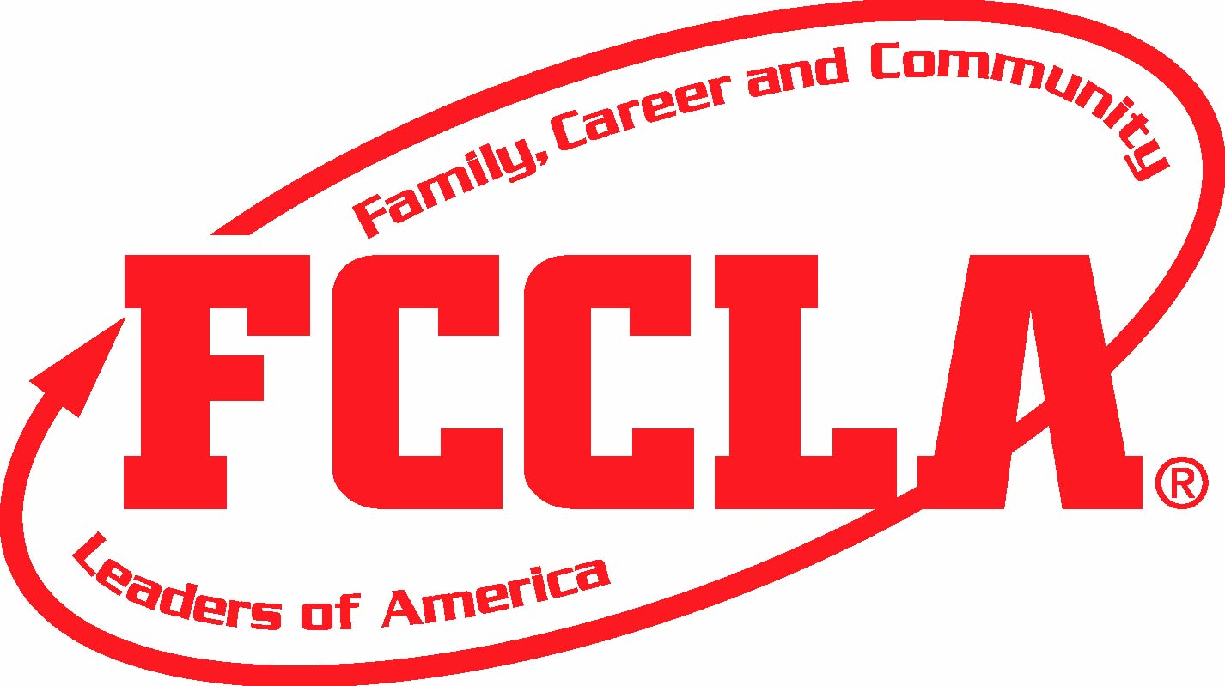
photo

( ½ of art foam board)

Art foam boards are usually 20 inches X 30 inches.
On the back, tape an index card with this information. (This part will be removed by state staff and kept)
Senior’s name | Chapter
E mail for senior | Home Address
Phone or cell phone | Future plans:
Career interest: | College they may attend:
Work plans: | Adviser’s name:
Why? We intend to contact seniors in the future and we want to honor all of your seniors.
Bring the posters to Registration Table areas of Ballroom Foyer area on March 28 between 3 and 4 pm.

