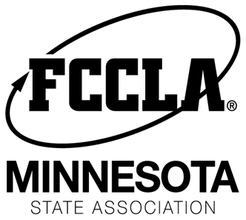
Ultimate Leader Award – 2017
MN FCCLA
Attn: Ultimate Leader Award
PO Box 131386
Roseville, MN 55113
Deadline February 7, 2017
New Award for MN FCCLA Members:
The Ultimate Leader Award is given to a Minnesota FCCLA member that nominated by their chapter advisor or other chapter member. The nominee must have displayed one of the Exemplary Leadership Traits: Model the Way, Inspire a Shared Vision, Challenge the Process, Enable Others to Act, and Encourage the Heart. Five people from across the state will be chosen for this award. The winners will receive recognition on stage and a prize pack at the FCCLA State Conference in March. Note: State Officers are NOT eligible from receiving the award. Please complete the following form and mail it to the address above.
Name of Person Nominating:_______________________________________

Are you a… (Circle One) Advisor or Member Chapter: _____________________

Name of Person Nominating Email: _______________________________________

Award Nominee: _____________________________ Grade: _____ Shirt Size: ____

Nominee Email: _______________________________________________________

Nominee Mailing Address: _______________________________________________

Nominee City: ______________________________ Zip Code: ____________

FIVE NOMINEES WILL BE SELECTED.
1. On a separate page, please explain in at least 7 sentences why this person should receive this award.
2. Please include examples of what this person has done to help your chapter be successful.
3. Please also explain what Exemplary Leadership Trait this person most exemplifies and why.

