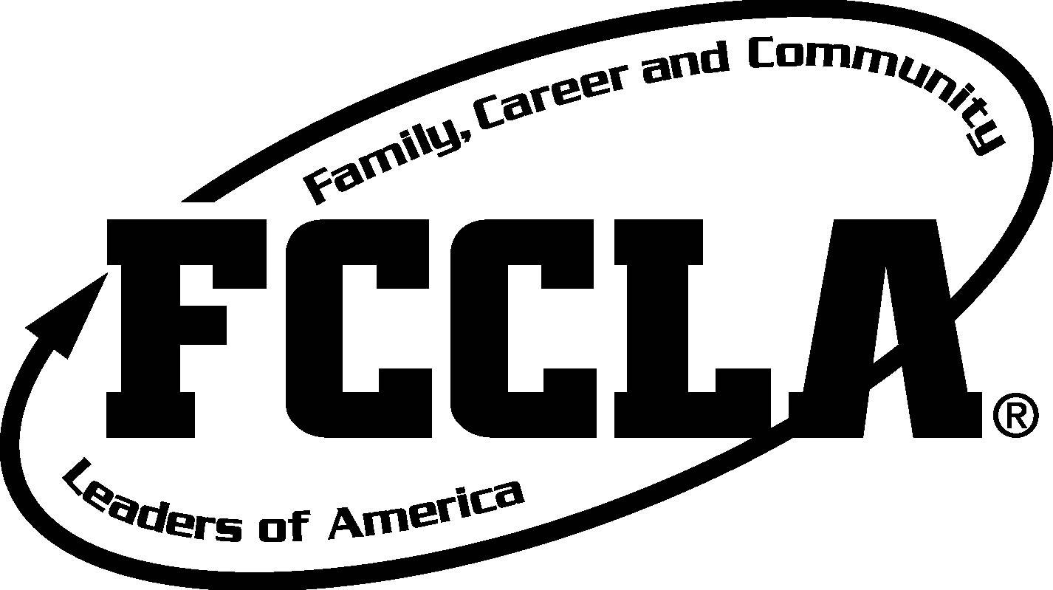
2017-2018 State Officer
Application for new candidates
Deadline for application via mail: February 10, 2017

The intention of this officer role is to continue your leadership experience building on the skills and knowledge you have achieved. The State Officer role has many facets which a MN FCCLA youth leader can continue to develop in an additional year.
- Current Officers (in grades 11 or lower) may apply for an additional year. This could result in a team larger than 8 state officers. The process of selection will be different than for new candidates. The possibility will be for 8 officers and additional repeating state officers to make up the Executive Council. Returning Candidates will be interviewed and will not be in the same process as new candidates.

Parts of the Application: Submit three (3) copies of your application and forms.
Please submit via hardcopy mail.
Application- -State Officer Candidate page 1
Candidates Code of Conduct page 2
Advisor Agreement- State Officer Candidate Advisor page 3
Parent Agreement- State Officer Candidate page 4

Submit Information:
Part 1- Resume
Part 2- Essay Questions
Part 3-Two Letters of reference
Part 4-Data information including Use of Photographic Likeness Agreement
Part 5- Attach a school transcript.
Part 6- Service Project work- Mini grant from Delta Dental or GYSDAY Project

APPLICATION –State Officer as Candidate Page 1
Candidate Name: ______________Chapter:_____________________
Rank these offices according to your interest. Officer placement will be determined by comparing all candidates strengths and interest  Rate your highest as #1 and least interested as #7.  The Board of Directors has committed to enforcing that June Exec Council attendance is mandatory.  If an officer is to miss any contract days, they need to seek and receive a written excused letter FROM the state Executive Director at least 2 weeks or more prior to the event to communicate that they are officially “excused” and have met the expectations for the assignments.  Note: Approval (a letter) may or may not be granted for pending absences. | Rank # 1 to 7  ___President Elect (2 year term)  ___Secretary  ___Treasurer  ___VP of Public Relations  ___Rep to the Board of Directors  ___VP of Service  ___VP of Resource & Develop.
State Officer Contract THIS IS AN AGREEMENT
The candidate, if elected, must agree to abide by the following. In addition, the adviser is expected to accompany the officer to Executive Council Meetings and to designated meetings. Officer expenses for meetings and events are paid by FCCLA. Adviser expenses are paid by the local school district.
__ 1. Yes | - I agree to attend Officer Training and Exec Council Meeting in April. April 8-9, 2017  Officers will develop teamwork and establish a new state theme during this meeting. | April 8-9, 2017
__ 2.Yes | 2. Yes, I agree to attend Camp Leadership Training- (Summer training) and the pre-meetings for Exec. Council. This has changed to a June week in 2017. | June 18-22, 2017
__ 3.Yes | 3. Yes, I will attend to the Legislative Shadow Day 2018. | Jan- March
__ 4.Yes | 4. Yes, I will attend all Executive Council Meetings. There is one in June, Sept, Nov, Jan and the Board functions at the State Conf. in April. I will communicate and negotiate any conflicts or deviations from the schedule with the Exec Director at least 1 month prior to the event. See note above about excused approvals. | June, Sept, Nov, Jan
__ 5.Yes | 5. Yes, I will be present at all of 2018 State Conference. The State Officer Adviser also attends. | April 2018
__ 6.Yes | 6. Yes, I know that I have the option to attend the National FCCLA meeting. The State Association may provide a $200 scholarship intended for the expenses of attending National Conference or Capitol Training at the conclusion of a successful term of office. The remainder of the funds must come from local or personal funds. Adviser is invited to chaperone, however, there is no state funding for adviser's attendance. | Optional:  2017 National Conference
__ 7.Yes | 7. Yes, I will promote and demonstrate the positive image of FCCLA
__ 8.Yes | 8. Yes, I agree to make FCCLA activities a priority over all other extracurricular school activities.
__9.Yes | 9. Yes, I will refrain from the use or possession of alcohol, drugs or tobacco during the entire term.
__10.Yes | 10. Yes, I agree to abide by all rules of conduct set by the State Association.
__11.Yes | 11. Yes, I realize I must always be eligible for the entire term of the office (academically eligible according to school rule standards).
__12.Yes | 12. Yes, I agree not to post social network communication sites or post videos that would identify me, identify myself as an officer or FCCLA member that would are not approved by the State FCCLA association. I agree to cooperate with the state staff as a friend on facebook and with social media policies established by MN FCCLA.
Non-attendance of agreed upon events and non communication would be reason for removal from office.
Process for removal will follow constitutional procedure (Article III, Section B).
Please check: 1. ___Yes, I the candidate, agree to the above responsibilities.
2. ___Yes, the candidate's school agrees to assist the officer and adviser, if elected, in assuming responsibilities listed above and with financial assistance.
3. ___Yes, the school will excuse the adviser from school for Exec. Council Meetings.
Signature of Adviser | Signature of Chapter President | Signature of Parent/Guardian | Signature of School Administrator
Yes, I pledge to abide by all of the above guidelines and carry out the responsibilities assigned to me.
Candidate _____________________________________________________ Date:__________________

APPLICATION Candidates Code of Conduct page 2
Minnesota FCCLA Leadership Positions

As a candidate for a State Officer position, you will be expected to follow the following Code of Conduct upon signing this form.
This becomes effective at the time you sign the application.

You will be representing your chapter, your region and the state association and the eyes of many people will be on you. What you do and how you do it should always leave a favorable impression. Your code of conduct should never be questionable. Read the following and sign before you continue with the rest of the candidate forms.

I, ____________________________________, agree to the guidelines and will promise to follow guidelines for myself from the time I sign this form.

I agree:

_____ I agree to set a good example for other elected individuals and FCCLA members to follow.

_____ I agree to strive to do my best in the role of FCCLA officer.

_____ I agree to make effective use of my time.

_____ I agree to strive to be positive in my encouragement of others.

_____ I agree to not drink alcohol beverages, use chemicals (drugs) or tobacco products.

_____ I agree to strive to have honorable and appropriate behavior in personal conduct and in the way I speak or act among my peers and adults.

_____ I agree to respect people within my school, local community and the FCCLA organization.

_____ I agree to not attend social events which I know will have the option to have alcohol, drugs or inappropriate behavior.

_____ I agree to seek ways to work as a team with my peers and adults in FCCLA.

_____ I agree to remain academically eligible in school.

_____I agree not to post social network communication sites or post videos that would identify me, identify myself as an officer or FCCLA member that would are not pre-approved by the State FCCLA association.
____ I agree to conduct myself as an ambassador of FCCLA and with good character and reputation for leadership and integrity on facebook and other social media sites.
____ On social media sites, I agree to become a “friend” of state staff on Facebook and allow them access to my postings and follow the social media guidelines established by MN FCCLA.

Signatures needed:
________________________________ __________ ____________________________ _________
Candidate Date Adviser Date

Keep one adviser copy, one school copy and send original copy to the MN FCCLA State Office enclosed in your candidate application.

ADVISER AGREEMENT- STATE OFFICER CANDIDATE ADVISER Page 3
Name of Adviser _________________________Candidate name: ____________________________ Chapter:_____________________________________
As adviser to a State Officer, I agree to the following.
See the proposed calendar of dates.
If an officer or adviser is to miss any contract days, they need to seek and receive a written excused letter FROM the State Executive Director at least 2 weeks or more prior to the event to communicate that they are officially “excused” and have met the expectations for the assignments. Note: Approval (a letter) may or may not be granted for pending absences.
____1. Yes, I agree to attend the designated dates for advisers to attend at the Officer Training and Executive Council Meeting in June.
____2. Yes, I agree to attend the designated dates Exec Council and Leadership Camp training FAILURE TO ATTEND SUMMER TRAINING WITHOUT PRIOR PERMISSION FROM THE EXEC DIRECTOR OR BOARD OF DIRECTORS WOULD BE GROUNDS TO CONSIDER REMOVING AN OFFICER FROM THEIR POSITION.
____3. Yes, I agree to be at the Shadow Day 2018 or see that the state officer has support for transportation and participation.
____4. Yes, I will attend all designated adviser attendance days of the Executive Council Meetings. There are meetings in April, (precamp) June, September, November, and January and the State Conference in April. Adviser or parent / chaperone or an approved sub must transport student.
____5. Yes, I realize that if an adviser has two state officers due to multiple chapters, an additional adult would accompany the second officer as a support to them and participate in an advisory capacity.
____6. Yes, I agree to participate as a State Executive Council team in good faith, arriving on time and leaving as designated when the event is completed.
7. Yes, I will support the state officer in their code of conduct and participation:
I agree
___ to support the state officer to assist them to attend the optional National FCCLA events if they choose. (at national conference, the state officer and adviser will attend all state meetings and leadership training)
___ to support the state officer to promote and demonstrate the positive image of FCCLA.
___ to assist the state officer make FCCLA activities a high priority.
___ to support the state officer to refrain from the use or possession of alcohol, drugs or tobacco during the entire term
___ to support the state officer to abide by all rules of conduct set by the State Association
___ to support the state officer to be eligible for the entire term of the office (academically eligible according to school rules).
___ to support the state officer to follow the social media guidelines and policies approved by the State FCCLA Association.
___ I agree to cooperate with the state staff to allow staff to be a “friend status” on facebook with the state officer.

Signature of Adviser:_________________________ Date:___________________________

PARENT AGREEMENT- STATE OFFICER CANDIDATE page 4
Name of Parent_________________________Candidate name:___________________ Chapter:_____________________________________
As the parent/ guardian of a State Officer, I agree to the following.
See the proposed calendar of dates.
____1. Yes, I agree to assist with the transportation for the State Officer to attend at the Officer Training and Executive Council Meeting.
____2. Yes, I agree assist with the transportation to attend the designated dates Exec Council and Leadership Camp training. FAILURE TO ATTEND SUMMER TRAINING WITHOUT PRIOR PERMISSION FROM THE EXEC DIRECTOR OR BOARD OF DIRECTORS WOULD BE GROUNDS TO CONSIDER REMOVING AN OFFICER FROM THEIR POSITION.
____3. Yes, I agree to assist with the transportation for the State Officer to attend the Shadow Day 2018 or see that the state officer has support for transportation and participation.
____4. Yes, I will assist with the transportation state officer’s attendance at the Executive Council Meetings. There are meetings in (precamp) June, September, November, and January and the State Conference in April. School transportation policies will apply for the Adviser or parent / chaperone to transport student. The Adviser may be attending designated days and transportation would needed to assist with the officer attending all days.
____5. Yes, I agree to assist the state officer to participate as a State Executive Council team in good faith, arriving on time and leaving as designated when the event is completed.
6. Yes, I will support the state officer in their code of conduct and participation.
I agree:
___ to support the state officer to assist them to attend the optional National FCCLA events if they choose. (At National Conference, the state officer and adviser will attend all state meetings and leadership trainings)
___ to support the state officer to promote and demonstrate the positive image of FCCLA.
___ to assist the state officer make FCCLA activities a high priority.
___ to support the state officer to refrain from the use or possession of alcohol, drugs or tobacco during the entire term
___ to support the state officer to abide by all rules of conduct set by the State FCCLA Association
___ to support the state officer to be eligible for the entire term of the office (academically eligible according to school rules)
___ to support the state officer to follow the social media guidelines and policies approved by the State FCCLA Association.
___ I agree to cooperate with the state staff to allow state staff to be a “friend status” on social media, facebook with the state officer.
Signature of Parent:________________________ Date:___________________________

Application- Officer Qualifications

Complete this section. Provide a written document with both the questions and information of your response. Finished responses should be no longer than three single-sided pages.

Part 1- Resume
Part 2- Essay Questions
Part 3-Data information including Use of Photographic Likeness Agreement
Part 4- Service Project work- Mini grant from Delta Dental Or GYSDAY Project
************************************************************************************
Part 1-Application: Resume- Develop a resume of your experiences that has this information. (One page limit-Size 10 font)
First name only is a direction for this section so that the committee is not influenced by family name or chapter name of the candidate.

Information for the resume
- First Name only
- Years that you have been a member of FCCLA?
- Grade Average in School (GPA or explain grading system)
- List the number of times you have attended (or participated in) each of the following and your involvement in:
  - Fall Regional Meeting
  - Mid-winter Regional Meeting
  - State Meetings
  - National Meetings
  - Cluster Meetings
  - FCCLA Camp and Leadership Training
  - Shadow Day
  - Capitol Leadership
  - Regional, State and National level STAR Events
  - MN FCCLA Skill Events
  - Other Experiences (list)
- List the FCCLA offices you have held and committees you have served on:
Chapter, Region, State or National
- List outstanding contributions you have made in your local chapter.
- List outstanding contributions you have made to your community.
- List outstanding contributions you have made in your school, school organizations that you have been a part of.
- Work experiences.
******************************************************************************

Part 2-Application: Essay Questions Limit: one ½ page per question.

Required Essay:

- Describe why you are an exemplary leader and how you are qualified to be a Minnesota FCCLA State Officer? Limit: one ½ page for this question.

- Refer to the purposes of FCCLA and tell how your involvement in FCCLA has impacted your life? Limit: one ½ page for this question

- Chapters have the opportunity to be involved in the national programs of FCCLA. These are programs such as STAR Events, Career Connections, Dynamic Leadership, Families Acting for Community Traffic Safety, Financial Fitness, Families First, Japanese Exchange Program YFU, Student Body, Power of One, Community Service, STOP the Violence and Service Learning. Describe how you have been involved in any of these national FCCLA programs. Limit: one ½ page for this question.

Answer at least 4 or more of these Essay Questions. You may choose to answer more than 4 questions.
- Describe or list your experiences with conducting meeting, participating in processes where parliamentary procedure was used. Limit: one ½ page for this question.

- Describe or list your experiences with doing public relations work. Limit: one ½ page for this question.

- Describe or list your experiences with financial management or as a treasurer of an organization. Limit: one ½ page for this question.

- Describe or list your experiences with a being a member of a governing board or a council or a board of directors. Limit: one ½ page for this question.

- Describe or list your experiences with community service, service-learning, Global Youth Service Day, Semester of Service activities, or other service opportunities. Limit: one ½ page for this question.

- Describe or list your experiences you have with being a secretary or a recording secretary of an organization or group, or have done communications work or taken notes at meetings. Limit: one ½ page for this question.

- Describe or list your experiences you have done with fund raising, developing a fund development plan, raising funds or contacting potential sponsors, seeking partnerships and donations. Limit: one ½ page for this question.

- Describe or list your experiences with STAR Events. Limit: one ½ page for this question.

************************************************************************************

Part 3: Submit two letters of reference with your application from persons who know your leadership abilities.
PART 4. Candidate Information-Submit three copies of the complete application
- Candidate Full Name
- Street Address
- Town, State, Zip code
- Home Phone
- Cell phone
- Candidate E-mail address
- Upcoming grade in school
- Candidate’s Parent/guardian
- Parent Address (if different)
- Parent e mail address
- School Name
- Street Address of School
- School Town, State, Zip code
- School Phone |  | ( )
- School Fax |  | ( )
- Street Address of School
- School Town, State, Zip code
- School Phone
- School Fax
- Adviser Name
- Adviser Street Address
- Adviser Town, State, Zip code
- Adviser Home phone
- Adviser Cell phone
- Adviser school phone
- Adviser school email
- Adviser home /summer
e-mail
- Principal's Name
- Superintendent's Name
- FCCLA Area_____ | - Jacket size:__________See chart below.
Female Candidates:
RED BLAZER – LADIES Circle the size you would need should you become a JHC Officer.
0 | 2 | 4 | 6 | 8 | 10 | 12 | 14 | 16 | 18 | 20 | 22 | 24
Male candidates-Choose one of the following men’s sizes:
RED BLAZER – MENS –REGULAR Circle the size you would need should you become a JHC Officer
36 | 37 | 38 | 39 | 40 | 41 | 42 | 43 | 44 | 46 | 48 | 50 | 52 | 54 | 56 | 58 | 60
RED BLAZER – MENS -LONG Circle the size you would need should you become a JHC Officer.
38 | 39 | 40 | 41 | 42 | 43 | 44 | 46 | 48 | 50 | 52 | 54 | 56 | 58 | 60
RED BLAZER – MENS –XLONG Circle the size you would need should you become a JHC Officer.
40 | 42 | 44 | 46 | 48 | 50 | 52 | 54 | 56

Part 5. Delta Dental Grant and/or GYSDAY Projects Available on Alliance with Youth website

https://fs16.formsite.com/MNYouth/form96/index.html

- Delta Dental Grant and/or GYSDAY Projects Available on Alliance with Youth website

https://fs16.formsite.com/MNYouth/form96/index.html

Option 1-A copy of the Delta Dental grant or a similar grant application
Option 2- Plan and Do a Global Youth Service Day (GYSDAY) Kick Off, Project and Celebration event for GYSDAY and submit your planning process for this community and school GYSDAY Event

******************************************************************************************************************************
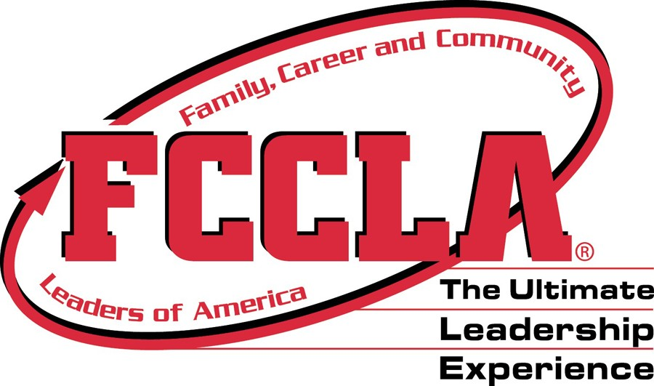
USE OF PHOTOGRAPHIC LIKENESS RELEASE

Name:____________________________________________________________
For good and valuable consideration, I authorize MN FCCLA and its agents to record photographs or other portraits or likenesses of me on videotape, audiotape, film, photograph or any other medium and use, reproduce, modify, distribute, and publicly exhibit such recordings, in whole or in part, without restrictions or limitation for any purpose that MN FCCLA deems appropriate. I further consent to the use of my name, voice and biographical material in connection with such recordings. I release MN FCCLA, its successors and assigns, agents, and all persons for whom it is acting from any liability by virtue of any blurring, distortion, alteration, optical illusion, or use in composite form, whether intentional or otherwise, that may occur or be produced in the recording process, or any unintentional misspellings or inaccuracies and waive any right that I may have to inspect or approve the finished recordings. I hereby release MN FCCLA, its staff, officers, members, partners, sponsors/funders, successors and assigns from and against any and all claims and causes of action whatsoever that I may hereafter have against MN FCCLA in connection with the above mentioned interview, written word, and/or photograph(s)/video and the organization’s social media or website.

Name:(Print) _____________________________________________________________________
FCCLA Chapter:____________________________________________________________________
Date signed:_________________________________________________________________________
Date of Birth:_______________________________________________________________________
Member- Signature if over 18 years:_____________________________________________________
PARENT RELEASE (Member is under 18 years of age)
Parent/ Guardian: Relation to subject (if subject is under 18 years of age) ____________________________________________________________________________________
Address __________________________________________________________________________
City, state, zip _____________________________________________________________________
Telephone ________________________________________________________________________
Signature:________________________________________________________________________

