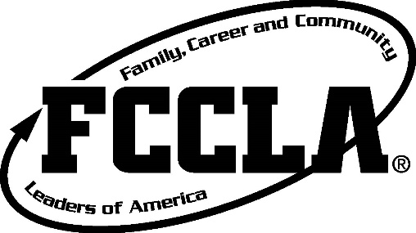
Minnesota FCCLA
Geographical Area Poster Contests

Minnesota FCCLA is excited to introduce the Geographical Area Poster Contests! Any member or a group of members may submit a poster.
Members will be creating a poster that promotes FCCLA, in any way. This could be a membership, service project, or just a poster that promotes FCCLA! Please note that you are not limited to those options, but it must promote FCCLA. Members will deliver their posters to their Area Fall Conferences at the Registration table, or otherwise noted at the Conference. Projects will then be graded by FCCLA Officers, Advisors, and other adults.
Each Geographical Area will have a winner. Every winner from the Areas will receive an award onstage at the State Conference in March 2017.

Rules and Eligibility
- The maximum poster size must be 22x28 in.
- Groups are allowed, but no more than 3 to a group.
- No posters will be accepted after the Closing Session of the Area Conference.
- You are welcome to use any materials to make the poster, but no glitter, tape, or any objects that could easily fall off.
- Individuals or teams should attach an information sheet with chapter and personal information.
Any violations of the rules will be subject to disqualification.
Rubric (25 points total)
Creativity | 5 | 4 | 3 | 2 | 1
Organization | 5 | 4 | 3 | 2 | 1
Clarity of Message | 5 | 4 | 3 | 2 | 1
Attractiveness | 5 | 4 | 3 | 2 | 1
Grammar | 3 | 2 | 1
Originality | 2 | 1

Participants Information
***Please attach this to your poster when turning your poster in.
Participant(s’) names: ________________________________________________________________________________________________________
Chapter: _____________________________________________

Advisor: _____________________________________________
Advisor or Primary Email: _______________________________
Advisor or Primary Phone number: (______)______-__________

