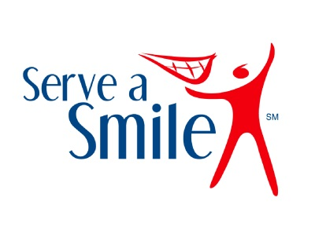

Delta Dental Serve a Smile Mini-grant Grant Opportunity!
Deadline: Friday, January 24th

The Minnesota Alliance With Youth, Delta Dental of Minnesota and FCCLA are pleased to announce the 11th annual Serve a Smile grant program. Delta Dental has made available over $25,000 for mini grants of up to $1,000 to support a youth-led service/service-learning project that addresses an important oral health or health issue. The mini grants will be awarded to youth affiliated with schools and youth-serving community organizations in Minnesota, offering young people essential funds as they envision ways to create healthier schools and communities.

Grant Overview, Project Examples and the Serve a Smile Application available at www.mnyouth.net. Submissions are due electronically by Friday, January 24th at 4pm. For more information contact Sarah Ullmer at sullmer@mnyouth.net.

