RESERVATION ROOMING LIST FORM INSTRUCTIONS

Open the attached Windows Xcel Document.
Enable Content
Click on the button labeled
“After you click this button let the spreadsheet update”

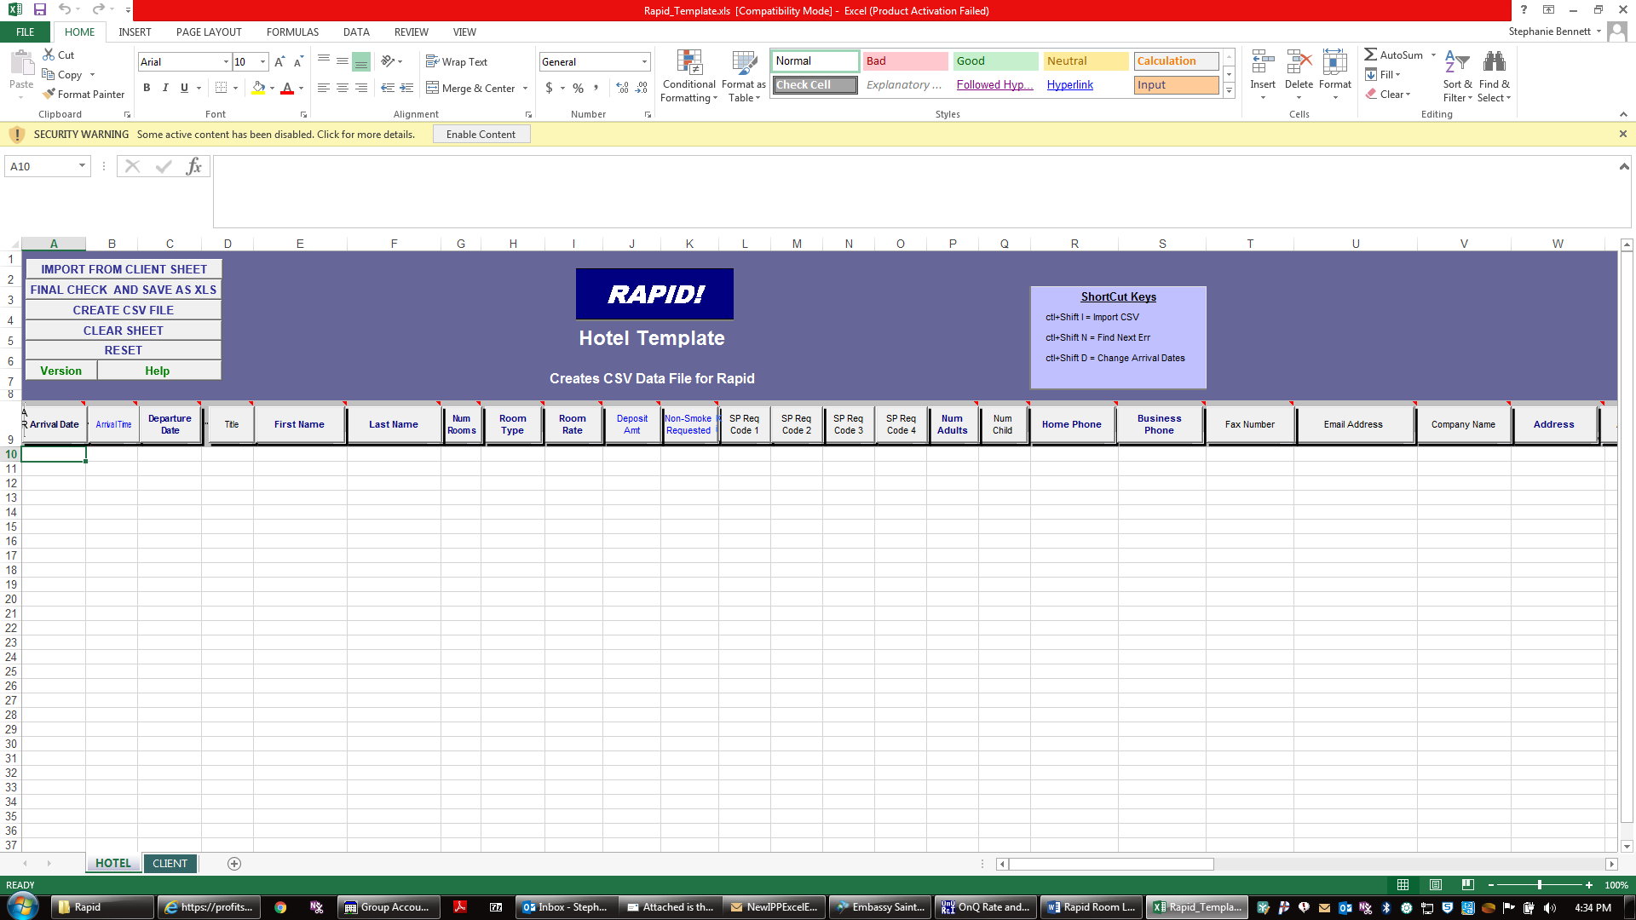

After the spreadsheet is done updating, please fill in the yellow highlighted cells. You do not need to fill in every cell just the yellow will suffice.

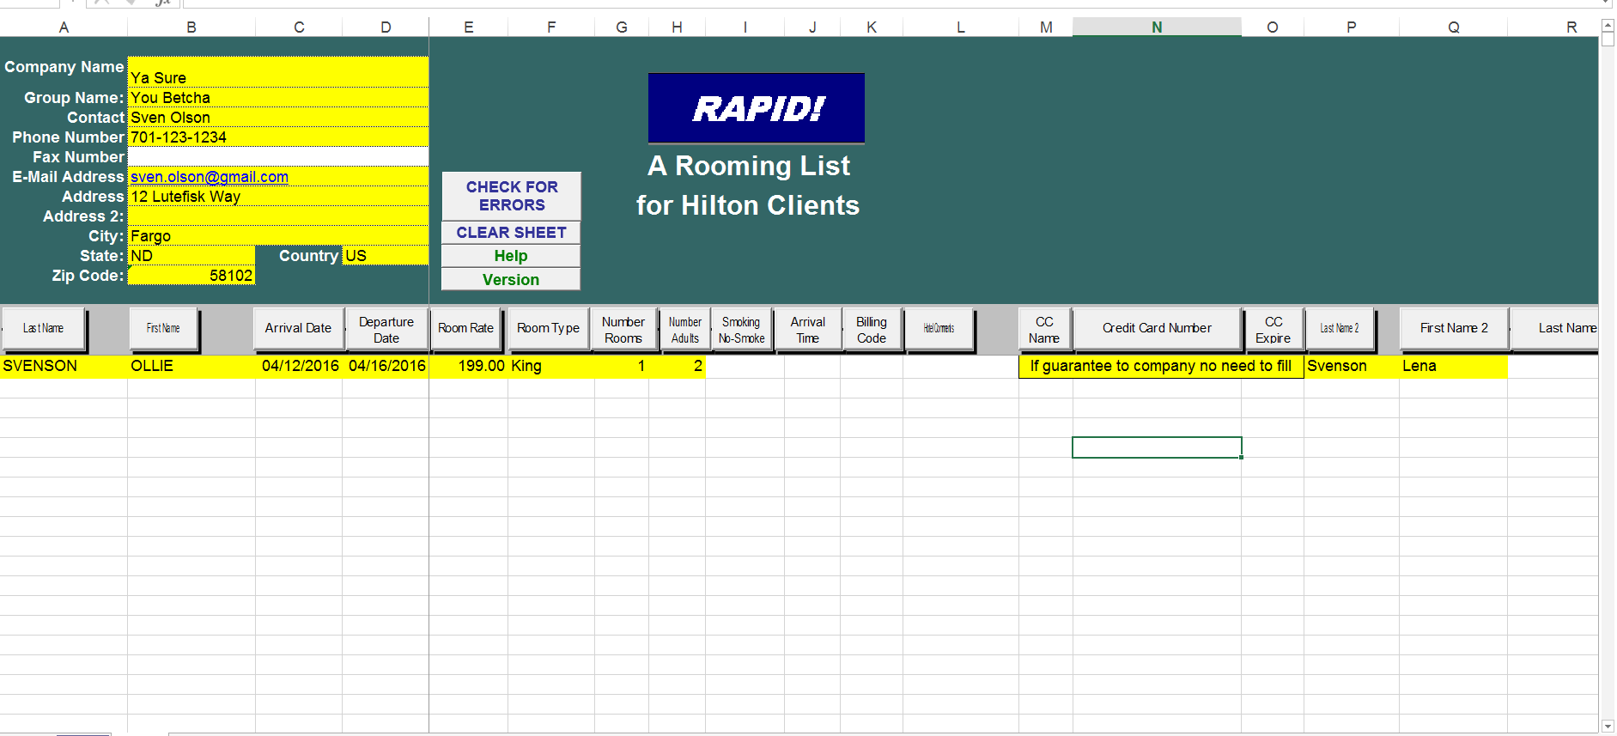

HOTEL
Then you will select the tab labeled
Import from Client Sheet
Select the
When the sheet imports it will automatically fill in the cells necessary to complete the form. You do have an option to add the individuals Hilton Honors number and e-mail address, then we can automatically send a confirmation to the attendee directly.

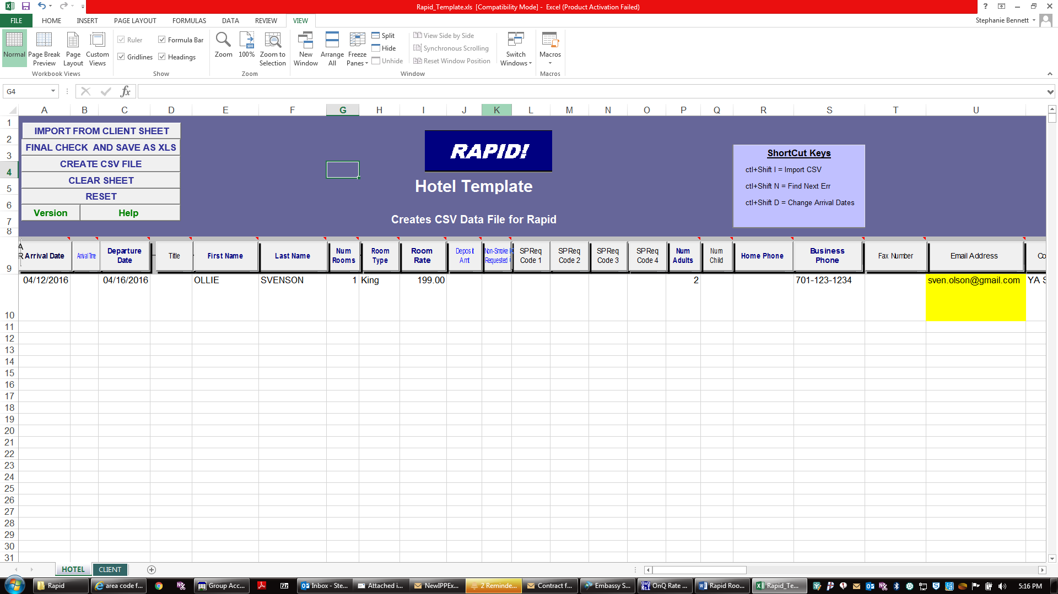

After this is complete select file save to update the form and e-mail to your conference service manager’s e-mail address.

